# **5th Story - Rebellions**

In the story titled *Rebellions*, the notion of an inescapable future is starkly challenged. The phrase ‘There is no alternative’*,* famously proclaimed by former British Prime Minister Margaret Thatcher, has become a somber anthem of a global neoliberal order, dictating the terms of economics, culture, and personal well-being. [1], [2] This slogan, entrenched in the political and economic discourses, implies a future devoid of transformative change, impacting not just the British political scene but also casting a long shadow over global work, education, and mental health.[3]

*No alternative* is an assertion of capitalist ideology about the only suggested way for social development; the capitalist economy is considered the best and unique system that can work. The debate about the alternative social systems supposedly ended in the last century with the decline and collapse of the Soviet Union. The slogan also conveys an optimism about how ‘Globalised capitalism, so-called free markets, and free trade were the best ways to build wealth, distribute services and grow a society's economy.’[4] Thatcher’s policies continue to influence the politics of today, contributing to despair and fear in large parts of society, especially among those who are oppressed, exploited and living in precarious situations created by unstable jobs and incomes. That is the idea of *no alternative* sharply portends *a future without hope for change*.

## **Community Dilemmas**

The growth of global corporations, especially the impressive achievements of high-tech corporations, has confirmed that *capitalism* is the *outstanding economic system*. These developments are intended to fill up society with the optimistic globalist flows associated with new techno-capitalist economies. Making a profit on digital platforms and AI technology has become the key method in the day and age. However, the broad influences, and the profound impacts of multinational technology conglomerates, also raise various questions about the operation of a market economy connected with superpower ownership or monopolistic competition. Ensuring social justice in a free, growing economy is becoming a challenge for contemporary societies. The feeling of *being lost* and *confused* in the matrix of the digital economy intertwined with *faith* and *fears* towards new technology generated a *global sense of dilemma* within societies.

To a certain extent, technological optimism is considered a general attitude in present society. At minimum, this perspective is reflected widely in mass media. Promoting technological achievements on news, radio shows, TV programs and YouTube channels is a familiar content. The economic policies and social action programs in various countries have special priorities for scientific and technological development. Techno-optimism has a tendency to rather emphasize the benefits than the drawbacks of technology to society. There is a common perception that human progress is achieved through overcoming obstacles. Life regularly raises various problems, questions, and mysteries; people need to find ways to solve them or reduce the consequences of those problems. From the invention of the wheel to the internet, technology is believed to have helped people to overcome ample obstacles or limitations. Scientific discoveries are considered to have made human life easier; technology is the promised potential drive for the development and progress of society.

Techno-optimism often criticizes Hollywood dystopian tragedies and argues that those are exaggerated fantasies. The society that will be decimated and destroyed by the rise of robots is an exaggeration; it is an attractive dramaturgical trick of film productions.[5] Meanwhile, optimists strongly believe in the union of man and machine. They are convinced by all the positive aspects of new-tech such as it may give ‘longer lives, less absolute poverty, fewer life-threatening illness, [and] more equality of opportunity’.[6] Those are the generally attributed values to technological developments.

Information technology and the internet are known as great inventions created to serve people. People are promised to have instant and unlimited access to all knowledge. This technology is able to make communication and social connection simpler, cheaper and more convenient. New technology is believed to have simplified all living activities, such as payment, scheduling, route finding, translations, shopping and entertainment. According to Miklos Sarvary - Professor at Columbia Business School, ‘platforms are creating so much value for consumers’[7] globally.

Particularly, it must be admitted that ‘Technology optimism was so deeply ingrained in the value system and in the beliefs of people in Silicon Valley’- the birthplace of hundreds of new technological discoveries every day.*[8]*  Technology corporations have spread strong beliefs about the transcendent world of the future associated with technological achievements for popular culture with large-scale marketing and communication strategies. The majority of tech leaders are constantly propagating the best things that technology will provide, like ‘We are doing it for everyone’, we ‘solve problems at scale’, ‘empower people’ and ‘make our services cost less and more connected’.[9], [10], [11], [12]

In fact, technological optimism is purposefully propagated to maximize the influence, expand markets, develop manipulation tactics and benefit businesses. Sundar Pichai - the CEO of Alphabet Inc. and its subsidiary Google - has emphasized the conglomerate’s ambition by introducing deep learning technology,

We've been focused ever more on our core mission of organizing the world's information. And we are doing it for everyone. And we approach it by applying deep computer science and technical insights to solve problems at scale. That approach has served us very, very well; this is what has allowed us to scale up seven of our most important products and platforms - to over a billion monthly active users each. And it's not just the scale at which these products are working, users engage with them very heavily*.[13]*

The worlds *engaging heavily* here means deepening the level of dependence of the user, a dependency with no way out. For example, let us imagine someone’s Gmail account suddenly disappeared - that would be the worst nightmare scenario not only for one single user, but for more than 1.5 billion people around the world.

The CEO of Microsoft from 2014, Satya Nadella also mentioned: ‘Our mission simply put is to empower you to create that tech-intensity in your organization, in your institution, so that you can have a broad, deep impact on the broader society.’[14]In addition,Mark Zuckerberg, co-founder of the social media platform Facebook also made clear his expansionist ambitions when, in 2021, he changed Facebook's name to Meta. He stated,

We want to serve as many people as possible, which means working to make our services cost less, not more. Our mobile apps are free. Our ads business model is an auction, which guarantees every business the most competitive price possible. And it worked. Billions of people love our products, we have hundreds of millions of businesses on our platform, and we have a rapidly growing ecosystem and a thriving business. That’s the approach that we want to take to help build the Metaverse, too.[15]

Techno-optimism has clearly dominated the perceptions of consumers and tied them to the services and products of the platform. Building loyalty ties was the strategy of feudalism in the past and performed by capitalism in the present. *Customer engagement methods* are the core activities to establish customer loyalty to techno-brands. The *loyalty business model* is applied widely in digital business management.[16] The main goal of this model is to build customer satisfaction that is the foundation for user loyalty and the basis for customer manipulation.

Based on the number of accounts that big tech platforms possess, the impact of these platforms is much broader than the influence of the national government. Billions of people are profiled and governed by technology corporations. With the *supranational* scale, millions of social problems have arisen within the platform’s society; however, the operating apparatus and staff of these corporations have been continuously simplified, reduced and automatized by intelligent computing, causing countless social problems that have not yet been fully solved.

The Arab Spring (2010-2012) is a remarkable example of the irresponsibility of social media platforms with important political issues that are deeply impacted by cyber activities.[17]

With the help of a Facebook page protesting abuses by the regime of Hosni Mubarak, in just 28 days, the activities of social media activist teams had led to the fall of the regime. Wael Ghonim, who played a prominent role in sparking the Egyptian Revolution of the year 2011, expressed to CNN reporters: ‘I want to meet Mark Zuckerberg one day and thank him’ shortly after the success of the revolution and the step down of President Muhammad Hosni Mubarak. But soon later, Ghonim bitterly said: ‘The hardest part for me was seeing the tool that brought us together tearing us apart. These tools are just enablers for whomever, they don't separate between what's good and bad. They just look at engagement metrics.’[18] Despite being asked to intervene in provocative developments that could lead to violence in Egypt, the Facebook platforms were silent and did not take any action.[19] Instead of giving hope to a *digital democracy*, many incitements to violence from social media have sparked bloody actions in this region. Marc Lynch of George Washington University stated in a Foreign Policy article, ‘There is something very different about scrolling through pictures and videos of unified, chanting Yemeni or Egyptian crowds demanding democratic change and waking up to a gory image of a headless 6-year-old girl on your Facebook news feed.’[20]

Inhuman political forces are able to use *technical tricks* to benefit from inciting violence,intervening in the truth and even interrogating and torturing their targets since they understand the *operating logic of algorithms* and the *technological loopholes*.With the ability to affect others anonymously, various political forces can attack individuals in numerous ways, such as sending spam or email bomb, hacking social media accounts or spreading fake news about the targeted victim.[21] In cyberspace, we witness an increment in the use of *cyber-torture* on a global scale. This problem has been alerted by specific UN reports of professor Nils Melzer in 2020.[22] States, organizations, and criminal groups are not only capable of conducting cyber-operations that cause critical suffering to countless individuals but do so for the specific purpose of torture. Cybertechnology may also be used to cause or contribute to severe emotional distress, most notably through intimidation, bullying, harassment, surveillance, public shaming, and defamation, as well as appropriation, deletion, or manipulation of information.[23]

Revolutionary activists and politicians have complained to Facebook about *troll factories* contributing to political instability in different regions of the world, but the silence was the most common solution by platforms. Another example, the fake news about Ukraine's political situation spread from Russian troll factories. Dmytro Shymkiv - a top adviser to Ukraine's president (from 2014 to 2018), met Facebook representatives and asked them to intervene in the proliferation of fake news about the Ukraine situation circulating on the Facebook platform. Shymkiv recounted the response from Facebook: ‘Sorry, we are an open platform in which anybody can do anything’.[24] In fact, Facebook did not care about fake accounts or troll factories that operated on their platform for a long time.

Fraud and cheating in cyberspace in general, and in social media in particular, have become a common and out of control problem in many places, especially in *developing countries* where legislation regarding technology are still inefficient. For example, various fake accounts were set up to mimic real users in order to misappropriate money from their relatives and friends. Scam investment, counterfeit goods business, and fake services through social networks have become common issues in developing regions, especially in South East Asia. Live stream sales have become a high-revenue business phenomenon in Vietnam since 2016. Most sellers will set up sales channels on social platforms, regularly livestreaming videos introducing real products at attractive prices. In numerous cases, customers receive counterfeit goods from these unknown online sales services. These livestream sellers often pay significant amounts to advertise on such as Facebook, allowing their live-stream videos to appear on the ‘news feeds’ of target audiences, even engaging in excess of 10,000 followers.[25] With the allurement of liveliness, skillful narration and attractive images, and a series of fake maneuvers (such as setting up a fake-buyer account system to interact, post and share), several livesteamers in Vietnam have earned up to 400,000 euros per month selling *knock-offs* through livestream methods on the Facebook. [26], [27] Nevertheless, there is a lack of regulation from both platforms and legal institutions to protect customers. In the current Vietnamese situation, no one seemingly controls the quality of the selling products and the trustworthiness of information in the advertisements on these platforms.

The existence of social problems arising from online advertising does not detract from the growth of this industry. On the contrary, online advertising creates new orders in popular culture. The emergence of digital stars on social network platforms has gradually replaced classical celebrities. For example, product reviews, tutorials, and entertaining videos on the Youtube platform have created new form of stars. YouTube Stars such as MrBeast, Jake Paul, And Markiplier have reached nearly 90 million YouTube subscribers and earned from 18 million to 54 million US dollars per year, and nearly half of their earnings come from the ad revenue. In addition, these stars have branded merchandise lines that have supported them or help them to make money.[28]

There are seemingly 1001 mysteries and business tactics in the operation of the information technology world. Edward Snowden mentioned:

The screen may be off as it's sitting on your desk, but the device is talking all of the time. The question - we have to ask is who is it talking to? Even if your phone is not hacked, right now, you look at it, it's just sitting there on the charger. It is talking tens or hundreds or thousands of times a minute to any number of different companies - who have apps installed on your phone. It looks like it's off, it looks like it's just sitting there, but it is constantly chattering. And unfortunately, like pollution, we have not created the tools that are necessary for ordinary people to be able to see this activity.[29]

Not many are able to understand the complex operating mechanisms inside the current computational system; in addition, various undisclosed digital business tactics drive *technological mysteries* to go further.Although the new technological terms such as artificial intelligence, machine learning, deep learning, Big Data, Internet of Things, and cloud computing are mentioned quite often in public media, the majority of ordinary customers are still far from knowing what exactly they are, how they work, and how they affect each user. With self-learning and self-making decision abilities, the performance of present AI systems even goes beyond human understanding capabilities.[30] The recent open letter with signatures from hundreds of the biggest names in the technology scene, including Elon Musk, has urged the world’s leading artificial intelligence labs to take a break in training new super-powerful systems for six months.[31] The letter pointed out that

Advanced AI could represent a profound change in the history of life on Earth, and should be planned for and managed with commensurate care and resources[…] Unfortunately, this level of planning and management is not happening, even though recent months have seen AI labs locked in an out-of-control race to develop and deploy ever more powerful digital minds that no one – not even their creators – can understand, predict, or reliably control.[32]

Moreover, the invisible strategy plans of tech-owners worsen the mysterious situation related to new-techs. According to Frank Pasquale, while technology has deeply pushed us into ‘the black box society’, where ‘powerful businesses, financial institutions, and government agencies hide their actions behind nondisclosure agreements, ‘proprietary methods’, and gag rules, our own lives are increasingly open books’.[33] For example, how do data broker companies collect information, where do they store it, how do they use the user's data, and for what? Those questions are the ‘obvious mysteries’ in our contemporary society. The mystery of the technology world might be one of the special arguments for the common *feelings of faith and fear* in new tech of users.

Martin Heidegger noted in the book *The Question Concerning Technology* that the modern people create an almost unscientific worship of science.[34] We seem to be overwhelmed by the ideas of efficiency and productivity related to technological achievements. Without awareness of the actual underground problems of new technology, the achievements of science may dangerously slip out of the public's control. Technology is not a mere instrument, it is not a mere neutral tool. It is created by humans and serves firstly serves human purpose to the benefit of its creators.[35] It is certainly true that the majority of present technology research centers, the birthplace of new inventions and applications, require a huge amount of capital to maintain research and experimental activities. The largest technology research centers in the world belong to or are sponsored by private corporations. States aim to gradually reduce public expenditures, and public finances are withdrawing from investment in research centers.[36] This drives a high concentration of private ownership of technology research centres globally. Hence, most current tech creations are from the orders of investors and aimed at serving corporations. In several cases, as with the US and China, developed countries could invest in technology research, although this may not be any different since most technological inventions serve the purposes of the ruling parties.

If the interests of the public are disregarded or even appropriated, technological achievements cannot obtain the promised values of tech owners. The *worship of technology* is rooted in the *public's fear and over-optimism* in tech achievements considered scientific truths. These truths are manmade results which reflect the mentality of a certain phase of time. Scientific records or conclusions can change according to the consensus of society at certain periods, as the American physicist and philosopher Thomas Kuhn demonstrated for a series of *paradigm shifts* in the history of human science.[37] Therefore, scientific optimism is a relative belief and we should perceive tech achievements as transitory developments. Moreover, there are various scientific conclusions that are manipulated and dominated by investors, the reason why the promised technological value or *current scientific truths* should always be taken into the consideration.

Taking a closer look at the reality of information technology abilities in the two years 2020 and 2021, at the peak of the *COVID-19 pandemic,* we see the *gains and losses* in the experimental period on the highly focused technology driven society. In the emergency context, plenty of incomplete and even potential risky technologies were still in use. Governments, organizations, education committees, and businesses normally spend years making decisions, but during the pandemic, they decided to apply new technology within a few hours. The most common defense was that inaction would result in greater damage. There are intertwined pros and cons, advantages and challenges, and beliefs and concerns regarding technology throughout the pandemic.

In the early stages of the pandemic, with daily reports of severe illness and high mortality, people feared that the science of the day was powerless against the forces of nature. However, reality has shown that humans are not helpless; pandemics are not uncontrollable. While the virus can breed in and spread from the wild, science and technology have made global epidemics a manageable challenge.[38] From first reports about a potential pandemic at the end of December 2019 to January 10, 2020, scientists had not only isolated the responsible virus but also sequenced its genome and published the information online. During the subsequent few months, health organizations introduced measures that would slow and stop the chains of infection. Several effective vaccines were placed in production in less than a year. In early 2021, COVID-19 vaccines were introduced into expanded vaccination programs in many countries. The world has never witnessed such a rapid response to a new pathogen. Although there were complaints about the side effects and sequelae of vaccines, one cannot deny the magic of science and technology that has brought people out of the dark-dead days of 2020 and 2021.

There were times when social communication had to entirely switch to cyberspace when the lockdown commands had been implemented in different areas. Many people had to work from home and communicate exclusively online for more than a year. Most universities and schools offered online classes in the same period. Information technology has proven its role in connecting communities, ensuring jobs and incomes for many employees who could switch to home office, maintaining the operation of organizations and businesses, and continuing their classes, training programs, and sociocultural activities.

New jobs on online platforms were born or developed during the pandemic period. The reduction of direct personnel due to the avoidance of mass infection sped up automated activities, such as automatic payment, shipment and check-in. To continue business activities in a situation of personnel instability, many companies invested in automatic machines to replace humans. In various fields, automation proved its efficiency; for example, with only 1.5% of personnel working directly on farms, the U.S. still provided enough domestic food, even becoming a leader in agricultural exports.[39] Another example, China has taken online shopping to a new level of development during the pandemic. With the unprecedented blooming of online sales, forecasting the future of e-commerce will profoundly affect our lifes. Automation will likely lead to job replacement, and fears of unemployment will persist alongside optimism about a future where people will be deprived of work.

Furthermore, the advantage of connectivity has also been accompanied by limitation of online activity, especially when physical contacts were almost completely eliminated due to the epidemic. International conferences, for instance, can be conducted across continents in a low-cost online format and still spread knowledge to many people, while elementary school students have struggled with their families and teachers with online learning and contactless education. The decrease in the quality of education during online semesters has been recognized widely in compulsory education schools or even in Universities. Online art exhibitions, live music shows on YouTube channels, or virtual museums seem to be only temporary compensation for the cultural needs of the population. Enjoying culture through these online mediums can hardly replace real artistic sensational feelings for audiences. In addition, living in forced isolated situations has increased the level of depression and mental crisis for many individuals. The lack of physical connection has obviously created significant mental harm to society.

In addition, there are potential risks in the forms of high-tech surveillance of the population first examined and applied on a large scale in many countries during the Covid period. The applications for personal biological reports, security cameras, and facial recognition systems used for surveillance of the public in many countries, especially in China. By monitoring smartphones, using millions of cameras to identify people in public, and requiring people to declare their personal medical status, authorities could efficiently identify suspected Covid-19 cases and trace their movements and potential contacts whom they may have exposed. A series of mobile apps had also been deployed to alert people about the infected cases.[40] Similar surveillance technologies were also applied in East Asian countries, Vietnam, and even Israel – when the government used *specialized* anti-terrorist technologies to monitor patients infected with Covid-19.[41]

In addition to the demographic, behavioral, and psychological data collected in cyberspace before, biometric data has also become an important target for governing during the pandemic. An individual's body temperature, heart rate, blood pressure, and medical history are compulsorily collected in many places, stored, and used without individual consent. When people have to choose between privacy and health, they have a tendency to prioritize *health*, which is the reason why personal information was considered less important during the pandemic. People found themselves in situation where they had to select one of the twol; however, they should have access to both privacy and health. People have the right to request that their information be used only to help them prevent or cure diseases; at the same time, their information should not be a data product that serves other political or business purposes.

Regarding high-tech surveillance, people tend to regard technology as a tool that assists the government to monitor the public; however, in fact, technology can also help individuals to monitor their governments. While there is only one-way surveillance, from top to bottom, there is potential for totalitarian government. Therefore, it is necessary to reinforce individual supervision toward governments and large corporations. For example, during the pandemic crisis, governments were generating revenue and spending large amounts of financial resources. The process of allocating various types of funds could have been handled in a more transparent way. In a transparent environment, citizens would have access to a range of information regarding decision-making strategies, distribution of services, and expenditures of public funds. They should have the right to control public money and make certain it is not misappropriated in corrupt ways. However, the actual COVID situation went in different a direction. In Vietnam, for example, monitoring the roll-out of COVID-19 prevention and control services had little transparency, leading to serious problems in use of fake testing kits. This led to the resignation of the President, an unprecedented event, and two Deputy Prime Ministers, and to the dismissal of the Minister of Health and three Deputy Ministers.[42] Additionally, in 2022, various companies in Vietnam were criminally prosecuted. Hence, *surveillance* should be balanced by a *counter-surveillance*, and the pandemic context was the best testing environment for citizens in many countries over the world.

An extraordinary situation like the pandemic is a unique rehearsal of a potential social form, in which digital technology is applied in almost every aspect of social activities. In other words, this historical event is a special case study for analyzing the current cyber circumstances and verifying the future speculations of a human society in which technology maximizes its role.

Technology has changed the world, supported people to *overcome obstacles and challenges*, and helped people solve mysteries. However, people also face various *consequences and problems* arising with the application of various technologies. Behind artificial intelligence technology, Big Data, the Internet of Things and Cloud computing there are a series of *environmental problems*. For instance, to make the global internet connection system work, an enormous amount of electricity is needed to feed the server farms, data centres, network infrastructure, fibre optic systems surrounding the earth, and electronic devices. One single Google search consumes the same amount of energy as a standard LED light bulb in use for three minutes, and if one considers the number of Google searches requested in a typical day, week and year, multiplied by the number of half the world's population, the sum is extraordinary.[43] Moreover, to run the entire digital industry, rare-earth metals such as lanthanum, cerium, neodymium, samarium, europium, terbium, and dysprosium have been mined exhaustively for the hardware manufacturing industry. Cobalt mining for lithium-ion batteries is a special example that raises concerns about environmental devastation in Congo.[44] On the one hand, digital technology created a simple and easy environment to connect people; on the other hand, it also pushed different social communities into various political, economic, cultural, and environmental crises.

Advanced computational technology contributed to the expansion of living space, and cyberspace became a new land for many individuals, offering new job opportunities, new study methods and new ways of entertaining. The optimism about an economy driven by technology, a future of *accelerated product commercialization*, and the efficient sales and delivery models of *programmatic advertising*, is accompanied by worries and doubts about *excessive stress*, the *loss of identity*, *private rights*, and the *right to self-decision making*.

New digital technology introduces contemporary people to utility worlds and the unprecedented intimate relationship between machines and humans. Face ID keeps users logged in on devices and apps, avoiding wasting time for multiple log-in activities, and that is how customers are maintaining a continuous digital profile and their active digital life in cyberspace. All user needs are recognized and responded to instantly by platforms. Virtual assistants are continuously there - in the car, in the house, in the pockets of numberless users to follow them, listen to their confidences and wish them goodnight daily. Is one able to forego the convenience and intimacy inherent in the technological world? One typical concern in communities is how ubiquitous monitoring of personal information deprives the user of control. The lack of transparency in the use of technology is a common phenomena. However, customers have a tendency to *ignore the drawbacks* and *accept the manipulated situation* created by tech owners, particularly through advertisements and propaganda messages, in exchange to use the free services and products of the platforms. Should people require both tech benefits and human rights? How can we solve the *tech dilemma* in the contemporary societies?

The ideological pressures of being unable to find solutions to social problems, and the idea that ‘There is no alternative’ have led a large part of our society to *nihilism* and the tendency to *normalize all problems in life*. As Jean Baudrillard wrote:

The apocalypse is finished, today it is the precession of the neutral, of forms of the neutral and of indifference [...] all that remains, is the fascination for desert like and indifferent forms, for the very operation of the system that annihilates us. Now, fascination (in contrast to seduction, which was attached to appearances, and to dialectical reason, which was attached to meaning) is a nihilistic passion par excellence, it is the passion proper to the mode of disappearance. We are fascinated by all forms of disappearance, of our disappearance. Melancholic and fascinated, that is our general condition in an era of involuntary transparency.[45]

A universal sense of *helplessness* and *impotency* of ordinary people contributed to the capitalist advantages. In developing countries in East Asia especially, nihilism and hyper normalization are deepening. As a fundamental part of Buddhist philosophy, renunciation is the method to end suffering. The culmination of the path that the Buddha taught was nirvana, ‘a place of nothingness […] non-possession and […] non-attachment […] which is the total end of death and decay.’[46] Therefore, there is a common attitude of distancing reality and leaving the current situation to occur according to the nature of the outside world. Each individual is advised to bring an end to suffering by *self-cultivation*. These ideas have contributed actively to the weakening of revolutionary ideas and criticism. In addition, the fear of change deeply rooted in the attitude of the postwar generations made them feel threatened by disillusionment with the aftermath of these revolutions. They are seeking stability that condititions them to accept social repression and unfairness. A major part of contemporary societies is facing the reality of hyper normalization.

All in all, in communities where everyone is frightened of change, it is that fear of change that actually feeds the power. In this day and age, in various places, people are forced to believe that ‘There is no alternative’.[47]

## **Finding The Way In The Digital Maze**

New computing technologies have brought both faith and fear, satisfaction and anxiety to society. The previous parts of this study attempted to depict the complex reality of the political economy, and to analyse different social problems that have emerged in the age of artificial intelligence and automation. Instead of falling into confusion, disorientation, and neglectfulness, people should cross over the ideological crisis after the postmodern period and, as Luke Turner suggested in his *Metamodernist Manifesto,* go beyond ‘irony and sincerity, naivety and knowingness, relativism and truth, optimism and doubt, […] we must go forth and oscillate!’.[48] By concrete acts of resistance and struggle, we can make changes, find new alternatives, rebuild more sustainable values, and sustain the existence of humanity. Though we know that ‘The revolutions are brutal, and this is the thing that one has to go back to if you want change. If you really want to change the world, you have to tackle power.’[49]

To make real change, we must revolutionize in different ways our methods and media; aside from the individual ones, collective actions are critical. In addition to guiding users to fair attitudes and lifestyles in cyberspace, we require a real change from legislators and executives and accurate actions from governments regarding the emerging issues in cyberspace. We may need to include radical acts, to force technology corporations to listen and communicate about existing issues, and soften the influence of consumerism on social culture. For more than a decade, many scientists, philosophers, sociologists, computer scientists, activists, and journalists have been active in discussing, making proposals, as well as participating in various social projects to respond to these social issues.

Writing about the influence of social media, Jaron Lanier, a technologist, futurist, computer philosopher and a founder of the field of virtual reality, offers arguments for abandoning social media.[50] He expresses how reliance on social media platforms reduces the capacity for spirituality and that users become automated extensions of the platforms. Examples revealed in his narrative show how users of Twitter and Facebook have become cruder, more tribal and less empathetic.[51]

In an earlier book, *Who Owns the Future*?[52] Lanier argues thatthe middle class is disenfranchised from online economies. By convincing users to provide personal information in exchange for free services, companies are able to accumulate large amounts of data at no cost. He called these companies *Siren Servers*, a reference to the Sirens of Ulysses. Rather than paying individuals for their contributions to the data pool, Siren Servers concentrates wealth in the hands of people who control the data center. As one solution to these problems, Lanier puts forth an alternative structure to the web based on Ted Nelson's Project Xanadu. He proposes a two-way linking system that would point to the source of any piece of information, generating an economy of micropayments that compensates online customers for original material posted to the web.

In addition to Lanier, other leaders in the tech world have stepped out of senior positions to focus on social change endeavors. Included among them are: Tristan Harris - director and co-founder of the Center for Humane Technology, Timnit Gebru- a computer scientist who run the Distributed Artificial Intelligence Research Institute (DAIR), Meredith Whittaker - President of the Signal Foundation, director of the AI Now Institute, Joy Buolamwini - computer scientist and digital activist based at the MIT Media Lab, etc,.[53], [54], [55]

They directly or indirectly became social activists. They have a profound contribution in responding to the social implications of artificial intelligence and related technologies. Although it is difficult to compare with the powerful acts of the technological, economic and political forces, these acts of resistance to the opposition have attracted great public attention and prepared the stage for a new development with much more consideration for human and moral values.

In 2019, innovative ideas for the 5th Industrial Revolution were proposed by Pratik Gauri & Jim Van Eerden.[56] They provided a humanistic vision for the evolution of industrial revolutions and a continuation of the 4th industrial revolution.

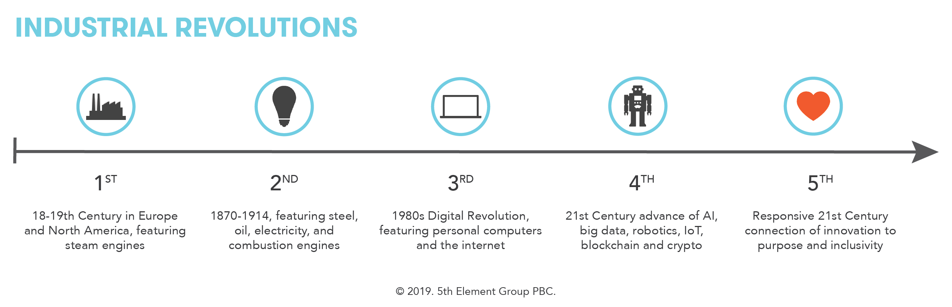

Figure S5. 1: Industrial Revolutions. Foto: 5th Element ©europeansting.com.

The first revolution began with the emergence of steam engines; the second revolution was characterized by the iron and steel, oil, electricity, and internal combustion engine industries; the third was the digital revolution that exploded with the advent of personal computers and the internet; the fourth revolution was notable for advances in a series of automation technologies, super artificial intelligent machines capable of self-learning, automated communication, stratified data analysis based on Big data and IoT. The fifth industrial revolution is predicted to be a combination of machines and humans wherein advanced technology is formulated based on ethics, humanity, and social responsibility to solve the existing limitations of previous revolutions.

Broadly, the innovation associated with social responsibility or *sustainable development* has become a main concern to the international community in recent years. It is clearly expressed in the *Sustainable Development Goals* (The Sustainable Development Goals - SDGs) of the United Nations Security General Assembly in in 2015, a set of 17 interlinked global goals designed to be a ‘blueprint for achieving a better and more sustainable future for all’.[57] The target for achieving the 17 SDGs is 2030.

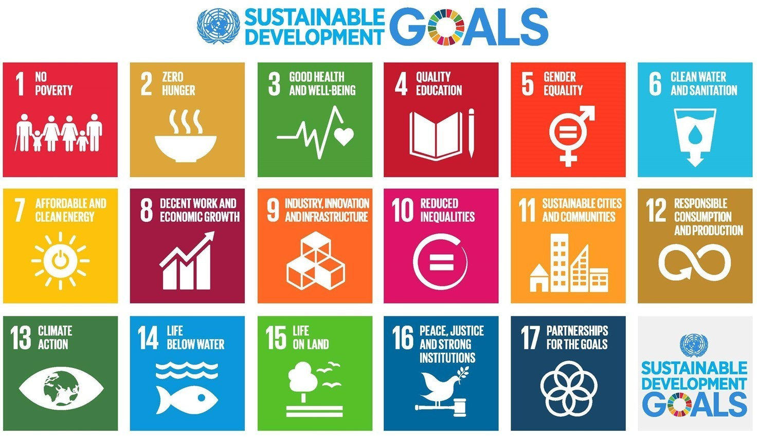

Figure S5. 2: The Sustainable Development Goals – SDGs ©Wikimedia Commons.

Therefore, social development associated with technology today must be linked to sustainable development goals. In the digital environment, especially, morals and humanity, social inequality, the digital divide, responsible consumption and production should be the principal focus of all development.

Issues related to the ethics of AI and its decentralization have become emerging concerns in international forums where sustainable development based on technology is paramount. There are remarkable contemporary concerns indicated in the book *The Oxford Handbook of Ethics of AI* published by Oxford University Press in 2020.[58] This book maps sharply the current production, application, and use of artificial intelligence in diverse spheres of individual, commercial, social, and public life by an interdisciplinary and transcontinental academic community. This handbook presents various approaches to the *Ethics of AI* conundrum. Nevertheless, the closest approach to the scope of this study is *human ethics toward AI*.

Since AI driven machines are entities capable of self-learning, self decision making, and even capable of expressing emotions, how will we relate to these machines? Should we treat them more like humans, or rather like animals? Should AI and machines have any moral status? With the posthuman approach, especially, these questions are among the main considerations. There are also countless issues generated through these questions. For example, should self-driving cars using AI be considered ethical agents? What kind of ethical competence should these AI machine have? How should AI be treated vis a vis moral status? Is artificial intelligence *just a machine*? Does it deserve ethical consideration? Should we treat it differently from a dishwasher or refrigerator? Should we just *unplug* and *kill* the machine when it poses a potential risk? According to the philosopher of technology, Mark Coeckelbergh, ‘Some argue that *mistreating* an AI is wrong not because any harm is done to the AI, but because our moral character is damaged if we do so.’[59] In another way, morality is a human idea and is about our attitudes.

Conventionally, human attitudes in a community are very multidimensional, and problems of bias, discrimination, and inequality have always been present in society. However, AI–with its potential for impact–is predicted to perpetuate these problems and deepen their impact. Therefore, the early prognosis and actions to prevent profound social effects of AI technology are an essential responsibility of contemporary society, before it is too late. Above all, the programmers, who produce and apply AI, need to have the right ethical attitude regarding the products they create, and be aware of the negative effects and possible consequences of technology. As Fei-Fei Li, a senior computer scientist in AI and computer vision, reminded technology engineers: ‘There's nothing artificial about AI. It's inspired and created by people, and most importantly it impacts people. It is a powerful tool we are only just beginning to understand, and that is a profound responsibility.’[60]

In addition, through explicit policies related to AI ethics, various social issues can be adjusted in time. Currently, the rapid growth of AI-generated art has left many artists concerned about a technologically advanced form of plagiarism. In early 2023, a group of San Francisco artists are taking legal action to reclaim copyright and consent by filing a class-action lawsuit against DreamUp, Midjourney, and Stable Diffusion.[61] They have discovered that an open-source AI-based image-generating tool called Disco Diffusion was using the work of many artists without their knowledge or consent. Similar issues need to be clarified and resolved in the context of legal regulations.

The transparency of AI and related new technology, in fact, has already been discussed to some extent in legislative bodies of several developed countries such as the US and the European Union. Examples of specific topics such as *Optimizing for Engagement: Understanding the Use of Persuasive Technology on Internet Platforms and The Risk of Manipulation and Deception in the Digital Age* have been discussed in the United States Senate and House Of Representatives in the years 2019 and 2020.[62] In April 2021, the EU Commission presented the *AI Issue Package*, including *Communication on Fostering a European Approach to AI*; a review of the *Coordinated Plan on Artificial Intelligence* (with EU Member States); and the proposal for a regulation laying down harmonized rules on AI (AI Act) and relevant Impact assessment.[63] These are considered the first actions for policies related to new technology issues and AI.

However, there are plentiful complicated issues and obstacles in policy decision-making process related to AI. Firstly, the rapid development of technology and its complex applications create elusive limits for the *lawmakers.* Secondly, the involment of multiple factors makes it difficult to attribute *responsibility* for the *rising problems*. Thirdly, there is the limitation of conflictuous views on *justice and fairness*. For example, creating a positive action toward disadvantaged individuals or groups remains controversial. Should justice be blind and unbiased, and, therefore, should algorithms be blind to race, or is justice meant to create an advantage for those who are already marginalized, thus leading to bias and discrimination? And should policy in a democratic context prioritize protecting the interests of the majority or focus on the interests of minorities?[64] Therefore, in a new technologically influenced environment, there must be a continuous improvement of the legal framework and a common consensus on the ethical views on new technology, especially regarding AI ethics. The concepts of justice and democracy should be considered case-by-case and implemented in a particular context.

Moreover, to limit monopoly control and create opportunities for democratic dialogue and build equality of rights in cyberspace, society needs to promote decentralized AI, decentralized social media, and decentralized public media. Regaining control of the internet and digital infrastructure is an important task ahead because it is the basic infrastructure of 21st-century society.[65] In addition, it is necessary to activate policies that encourage and create conditions for small technology research centers, protect the interests of start-ups, limit the manipulative power of corporations, raise awareness against the exploitation in cyberspace, fight for the rights of users, and introduce and apply alternative trustful products and services. These are the initial practical actions aimed at *decolonizing cyberspace*, which reduces and eliminates the influence of supranational platforms presently holding the overall control over the future of AI.[66]

CryptoParties are forms of decentralized initiatives that gained prominence in the global online community in recent times; by joing this movement, users are able to learn how to improve their digital privacy and security.[67] CryptoParties introduce basic cryptography tools–such as the Tor anonymity network, public key encryption (PGP/GPG), and OTR (Off The Record messaging) - to the general public. There is a CryptoParty handbook–an open source document downloadable for free on many forums. Readers are able to access useful information such as tips for using email safely, how to prevent tracking when using browsers, how to keep passwords safe, and how to safely circulate files on the network, a wide range of alternative applications with open-source codes are introduced.

Taking action on the copyright issues related to AI-generated art tools, a team at the University of Chicago introduced a free-to-use *Glaze* software in March 2023 to help protect original artworks.[68] A layer of data invisible to the human eye has been added over images that *acts as a decoy* for AI. Theoretically, if generative AI encounters an image that has been protected by Glaze, it will be unable to accurately analyze and replicate its style.

In addition to the mentioned micro solutions, researchers and policymakers are interested in solutions at the macro level–predicting or forming new social paradigm scenarios. In the book *Superminds: How Hyperconnectivity is Changing the Way We Solve Problems,* Thomas W. Malone outlined a vision of a *cyber‐socialism* in which he points to the social credit system that China has placed in trial applications in recent decades as an example. [69], [70] By connecting it to the false legacies of historical socialism, he highlights that the problems of information technology controlled *social credit system* are being reproduced in Chinese experimental version. For example, there is a widespread deprivation of privacy; personal data is exposed to the public and manipulated by social regulators; individuals live without private ownership; all aspects of life are assessed through social value scales and ranking; and reputation and social contribution are the social measurement tools. It is a dystopian scenario of IT-enabled socialistic decision-making that Thomas W. Malone is trying to connect with the idea of cyber-socialism. Meanwhile, we continue to witness the loss of personal data, the loss of self-determination, the misleading value through rankings and ratings, and personal reputation within the IT products of the contemporary capitalist economic system.

Malone’s model is not the only form of cyber socialism that the world could follow; the socialistic decision-making models of Nordic countries such as Estonia could be mentioned as well.[71] Another proposal towards the collectivization of ownership of social capital with emphasis on technological capital is introduced in the work *Inhuman Power - Artificial Intelligence and the Future of Capitalism.* Authors Nick Dyer-Witheford, Atle Mikkola Kjøsen, and James Steinhoff have made in-depth analyses of the ownership of AI capital, forecasting that AI will entirly unmake the old modes of productions, and automated methods will gradually take over the full economic system. The authors also mention as a suggestion:

A communist orientation to AI takes as its priority neither halting AI (Luddism) nor intensifying its development (accelerationism) but rather liquidating the structural dynamics of capital that have so far fostered its development […] the most promising parts of postcapitalist/left-accelerationist programmes are not those that advance the automation of work within capital, but rather those that point to the expropriation of AI-capital, the development of new forms of *collective ownership of AI*, and the application of AI to the collectivization of other sectors.[72]

They also believe that if realized the ‘fully automated luxury communism, or postcapitalism, envisages a transition to socialism by reducing or eliminating the need to work and supplying a universal basic income.’[73] However, *Inhuman Power* also recognizes the limitations and difficult realities of achieving a model of technological communism. In conclusion, they wrote ‘AI-capital is an abyss, communism a bridge across, but a perilous, shaky one, partially in flames, and with an obscured arrival point on the other side: nonetheless, advance.’[74]

John Perry Barlow, co-founder of the Electronic Frontier Foundation (EFF), published *A Declaration of the Independence of Cyberspace* (1996) in which he states, ‘These increasingly hostile and colonial measures place us in the same position as those previous lovers of freedom and self-determination who had to reject the authorities of distant, uninformed powers. We must declare our virtual selves immune to your sovereignty, even as we continue to consent to your rule over our bodies.’[75] Technology will continue to be developed and applied following human existence, in order to to be a means of support, serving the common interests of all people. Technology should not be a tool of exploitation, oppression and manipulation by a small group. On a global level, contemporary society must take action, even radical revolutions, to achieve synchronous management of evolving technological issues.

## **Artistic Warriors**

In *Artistic Warriors*, the narrative weaves through the rich tapestry of human ingenuity, emphasizing our innate role as designers of both our environments and fates. As a species, we employ structured methodologies not just in the creation of tangible objects but in every facet of our existence—from shaping social systems to scripting personal interactions.[76] The act of design, deeply embedded in our survival instincts, has evolved from primitive shelter construction to the sophisticated orchestration of modern societies. Throughout history, every sentence formulated, every shelter erected, and every garment crafted is a testament to our relentless experimentation and adaptation. Today, our scope has broadened; we design not only the physical but the abstract, influencing social constructs and even the design processes themselves.[77] This story reflects on how these multifaceted design activities are not just acts of creation but powerful tools for reshaping our postcolonial reality, challenging the remnants of imposed structures and envisioning a world where design serves as a conduit for liberation and transformation.

Currently, it's essential to view design phenomena through the lens of their interactions among traditional design disciplines and other fields. Many modern design endeavors integrate various art forms and social activities, encompassing graphic design, web design, filmmaking, and even social movements like protests and occupations, as well as legal actions. Both art and design serve as potent mediums that articulate creators' visions, ideas, and intentions, while also addressing everyday human needs. The relationship between art and life has been tightened throughout human history. Expanding the idea of art seems inevitable since social complexity is an obvious fact. Art increasingly requires its own involvement in questioning and answering for reality as well as liberating the artist from social limitations. As Guy Debord wrote in *Internationale Situationist (Paris), No. 1, June 1958*: ‘Art need no longer be an account of past sensations. It can become the direct organization of more highly evolved sensations. It is a question of producing ourselves, not things that enslave us.’[78]

Facing social problems, artists, designers and creative workers make a significant contribution together with other field practitioners by drawing social attention to the emergent issues; they are the active agents for social change. Design deals with multiple tasks; it is no longer just a means to solve a single problem, a tool to create commercial products, but it is also a mechanism to understand society as a whole, a tool for manifesting, criticizing, negotiating, educating and prototyping the future of human beings. We can consider the most explicit social form of art. Taking the classical design processes, the contemporary design projects regularly show a blend of imagination, research, planning, experimentation, and decision-making to produce the design results. Indeed, this is the reason why research-based methods are a remarkable characteristic of design practice.

In general, there are numerous social issues that have occurred among various design interest topics, from those related to democracy, autonomy, equality, feminism, and colonization, to consumption, trade, environment, and medicine. Contemporary design has several common approaches to problems, such as the depiction, evaluation and criticism of the current situation, proposal, test, and practice solutions to create positive social changes and increase social benefits.

Currently, the major part of socially engaged contemporary design works focuses on depicting, evaluating, and critiquing reality and experimenting and practicing micro-solutions. However, the need for macro-solutions has become more and more significant, since many social problems cannot be solved without systemic change. As Walter Benjamin elaborates in his article *The Work of Art in the Age of Mechanical Reproduction*

The transformation of the superstructure, which takes place far more slowly than that of the substructure, has taken more than half a century to manifest in all areas of culture the change in the conditions of production. Only today can it be indicated what form this has taken. Certain prognostic requirements should be met by these statements. However, theses about the art of the proletariat after its assumption of power or about the art of a classless society would have less bearing on these demands than theses about the developmental tendencies of art under present conditions of production. Their dialectic is no less noticeable in the superstructure than in the economy. It would therefore be wrong to underestimate the value of such theses as a weapon [...] They are useful for the formulation of revolutionary demands in the politics of art.[79]

By embracing political action and social involvement, Social Design, Critical Design, and Design Activism are typical *design activities* most associated with social issues in recent years. These design practices initially belonged to the counter-design movement, alternative dialogue methods with various power forms; currently, these practices have gained a positive impact on the design mainstream. These socially oriented design dialogues have demonstrated globally the efforts of artists, designers, and creators. In particular, sustainable design is highlighted in the present design world. To briefly depict the picture of socially engaged contemporary social designs, the following part of this writing will introduce several related examples of exhibitions, art projects, artworks and art activities.

*Social Design*

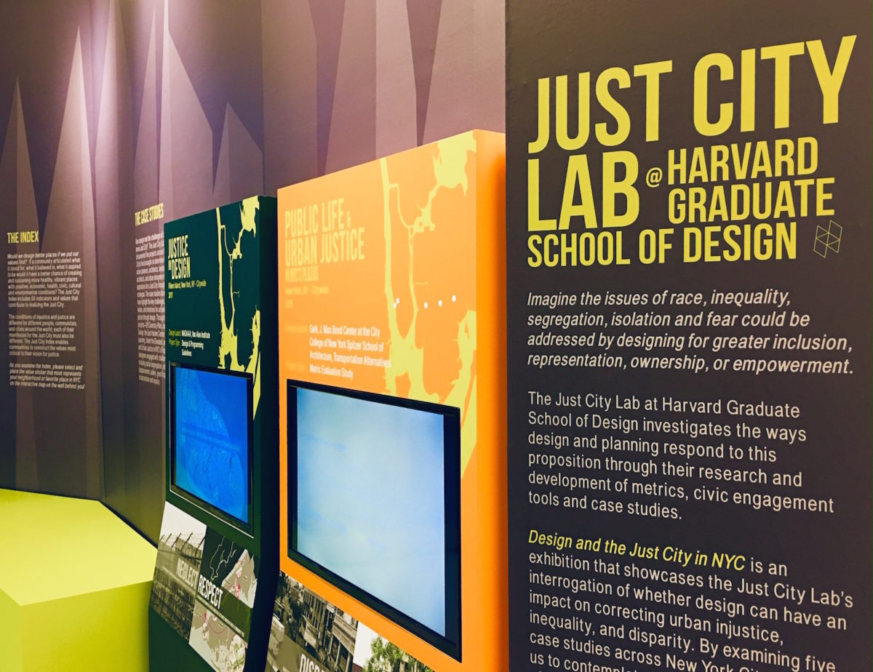

Figure S5. 3: Design and the Just City ©gsd.harvard.edu.

*Design and the Just City* - Harvard Graduate School of Design, at AIA’s Center for Architecture, USA 2018.[80] The exhibition focused on how design and planning contribute to equitable and unjust conditions in cities, neighbourhoods, and public areas and asks whether design can have an impact on correcting urban injustices, inequalities, and disparities.

**

Figure S5. 4: Social Design ©museum-gestaltung.ch .

*Social Design* at Museum für Gestaltung, Zürich, Germany 2019.[81] The exhibition aimed to confront the rapidly growing imbalance of resources, means of production, and future opportunities. Solutions were considered relying on the new, equitable exchange between individuals, civil society, the state, and the economy. Given that condition, many architects, designers, handicraftsmen, and engineers all developed various solutions through their works.



Figure S5. 5: Social Design Exhibition Asia ©red-dot.cn.

*Social Design Exhibition Asia* at Red Dot Design Museum, Xiamen, China 2020.[82] The Asia Social Design Expo featured more than a hundred the global social design units from 20 countries and regions. The exhibition theme included circular economy, disaster response, educational diversity, minority care, and urban innovation. The exhibition introduced the ways design energy solves social issues and creates a better society.

**

Figure S5. 6. Common objects. Local stories, global discussions ©Tra Nguyen.

*Common objects. Local stories, global discussions* at Design Museum of Barcelona, Spain 2022.[83] There was a Global Debates section which focused on the dialogue designs to reflect their social role as mediators. The exhibited works were persuasive objects that actively demonstrate their role in building a better society.

*Critical Design*



Figure S5. 7: Dunne & Raby, Evidence Dolls, illustration: Abäke, photo: Jason Evans ©e-flux.com.

*Evidence Dolls* - Dunne & Raby was one of the artworks shown in the ‘No. 15 Designing Critical Design’at Z33 House for Contemporary Art, Design and Architecture, Belgium 2007.[84] This was an early critical design exhibition. The exhibited designers distanced themselves from the modern world of commercial design but they still use the mechanisms of that very world to question the discipline and technology, social and ethical questions.

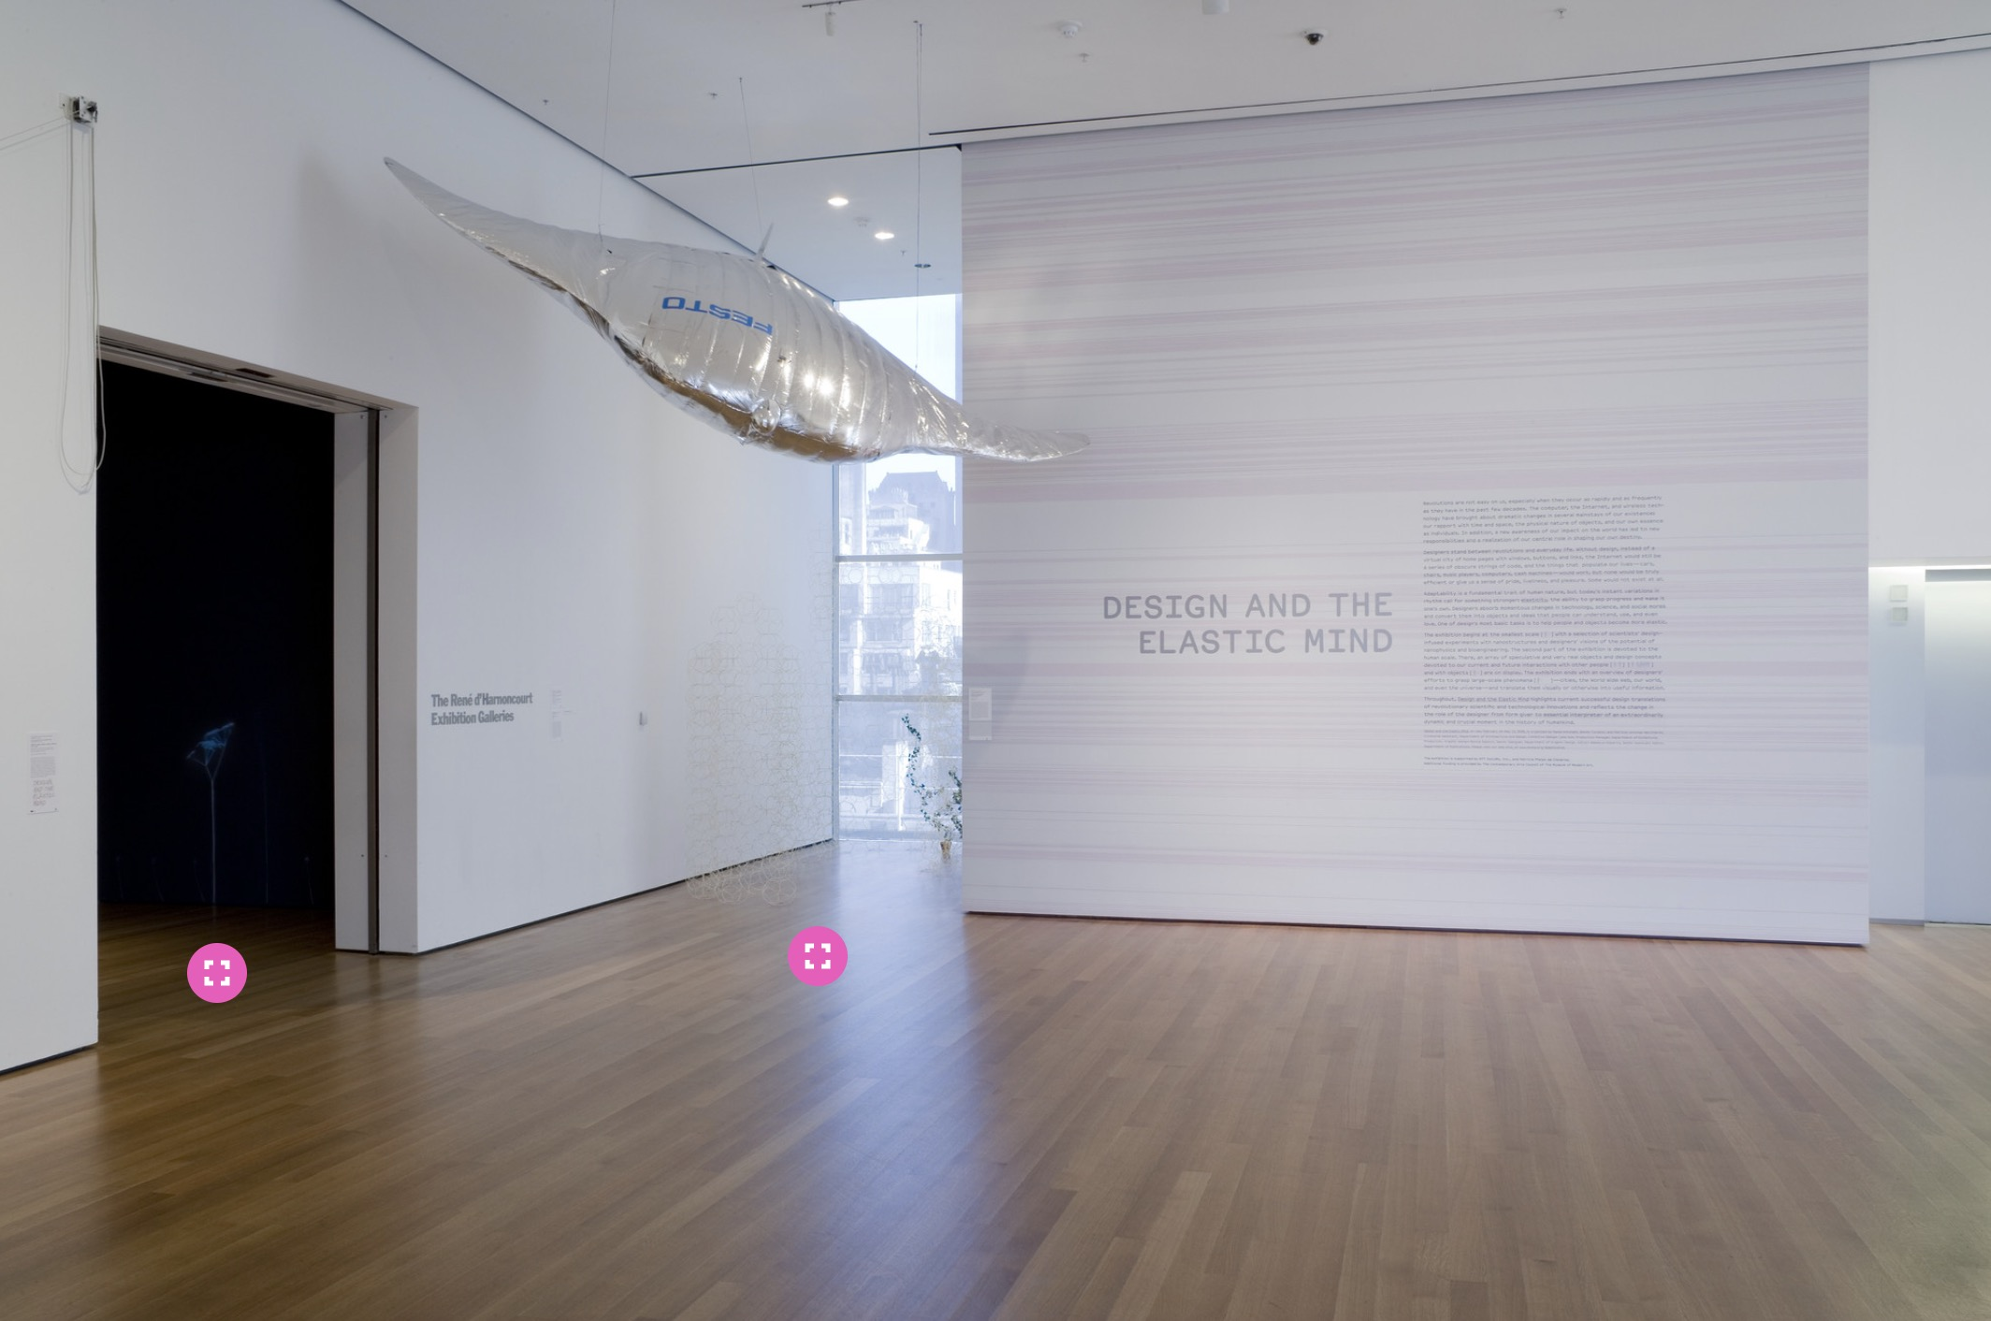

Figure S5. 8: Design and the Elastic Mind ©moma.org.

*Design and the Elastic Mind*at MoMA, New York, USA, 2008.[85] The exhibition focused on momentous technology changes, science, and social mores. These changes were supposed to require major adjustments in human behavior and turn them into objects and systems that people understand and use. The exhibition included objects, projects, and concepts offered by teams of designers, scientists, and engineers over the world. It ranged in scale from nanodevices to vehicles, from appliances to interfaces, and from pragmatic solutions for everyday use to provocative ideas meant to influence people future choices.

*Design activism and artistic activism*

In addition to peaceful critical design or contributed social design, we also witness more radical design actions from tactical media and collective art. Design activism, also known as artistic activism, is a practice method with resistant actions such as protest, hacking, and occupying, in which graphic design is an early active involved form. With the traditional propaganda functions, graphic works are considered an important design form in initial artistic activism projects.



Figure S5. : Design activism and artistic activism. The Raised Fist, a symbol of solidarity, 1917. Black Lives Matter Murals, 2020. The Peace Symbol, the official logo for the British Campaign for Nuclear Disarmament, 1958. ©shillingtoneducation.com.[86]

Tactical media is a specific example of using interdisciplinary methods in art activist action. In tactical media projects, the role of art is emphasized.[87] Some prominent representatives of tactical media practice include The Yes Men, Critical Art Ensemble, and RTMark. The majority of tactical media projects include the use of design as a tool to denote resistance scenarios.

The Yes Men are a duo of culture-jamming activists and supporters network founded by Jacques Servin and Igor Vamos.[88] One of the most famous jokes of The Yes Men was to put a *corrected* World Trade Organization (WTO) website at http://www.gatt.org (General Agreement on Tariffs and Trade).[89] The fake website began receiving real emails from confused visitors, including invitations to address various elite groups on behalf of the WTO, and they responded as if they were the real WTO.[90] At the WTO, in October 2000, the Yes Men gave speeches encouraging corporations to buy votes directly from residents. They then started a performative action, introducing a gold spandex body suit implanted with sensors. They declared that the wearing of this suit would improve worker productivity since managers would no longer need to personally oversee workers but could track them via screen images and the implanted sensors.

The Critical Art Ensemble (CAE) is another collective of five tactical media practitioners from many disciplines, including computer graphics and web design, film/video, photography, text arts, book arts, and performance.[91] The collective has written seven books and their works have been translated into 18 languages. Their books include: The Electronic Disturbance (1994), Electronic Civil Disobedience & Other Unpopular Ideas (1996), Flesh Machine: Cyborgs, Designer Babies, & New Eugenic Consciousness (1998), Digital Resistance: Explorations in Tactical Media (2001), Molecular Invasion (2002), Marching Plague (2006), and the project book Disturbances (2012). Regarding the topic of their activities, in the 1990s, CAE mainly focused on projects related to the interrogation of biotechnology; since 2006, they have changed the focus of their work towards a critique of US defence policy.[92]

RTMark is a notable anti-consumerist activist collective whose main focus is to break the *Corporate Shield* that is *protecting* American corporations.[93] RTMark is a registered company that brings together activists who plan projects with sponsors who fund them. As a result, it operates outside the laws governing individual human beings and benefits from laws governing much looser corporations. RTMark claims their first prank was the *Barbie Liberation Organization* in 1993.[94]

*Act of designing in the age of AI and automation*

Reacting to new technological challenges, especially the rapid development of machine learning and automation, there are significant contributions of designers and art creators. In addition to applying AI as an aid to design and the making of art, some artists have considered AI and automation as a social phenomena, using design and art to interrogate, criticize, and offer solutions.

*Face to Facebook* by Paolo Cirio & Alessandro Ludovico – Duo Italian artists - is one of the early projects that reacted to the data collecting problem.[95] *Face to Facebook* is considered a form of art hacking that appeared in The Art Of Hacking of Juli Laczkó. According to Laczkó, in 2011, Cirio and Alessandro Ludovico copied one million Facebook profiles (profile pictures, names, locations), and then, with the help of an algorithm, by selecting and categorizing a quarter of a million identities with smiling profile pictures, they created the lovelyfaces.com dating site, inciting mass media coverage and public outrage, which Cirio and Ludovico documented with satisfaction as a Global Mass Media Performance. Over a five-day period, more than a thousand articles and reports had been published. Identical to Facebook's business model, the project had turned publicly and voluntarily shared user data into their interests. The work has left an open question about who has the legal right to exploit user data. The artists consistently identify the work as appropriation and awareness-raising.[96]

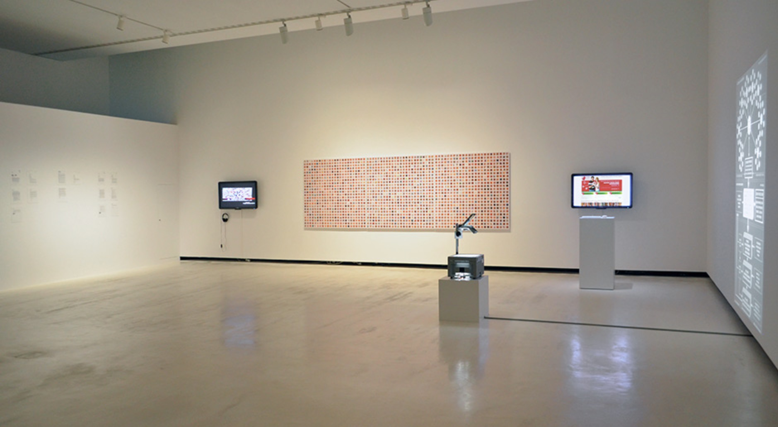

Figure S5. 10: Face to Facebook by Paolo Cirio & Alessandro Ludovico ©paolocirio.net.

*Technologies of Care*​ (2016) by Elisa Giardina Papa–an Italian artist based in New York documented new ways in which service and effective labour are being outsourced via internet platforms. It explored various topics such as empathy, precarity, and immaterial labour in the body of the work. One of its episodes, *Worker 7 - Bot? Virtual Boyfriend/Girlfriend* documented the real story of the three-month-long affair the artist had with an interactive chatbot.[97]

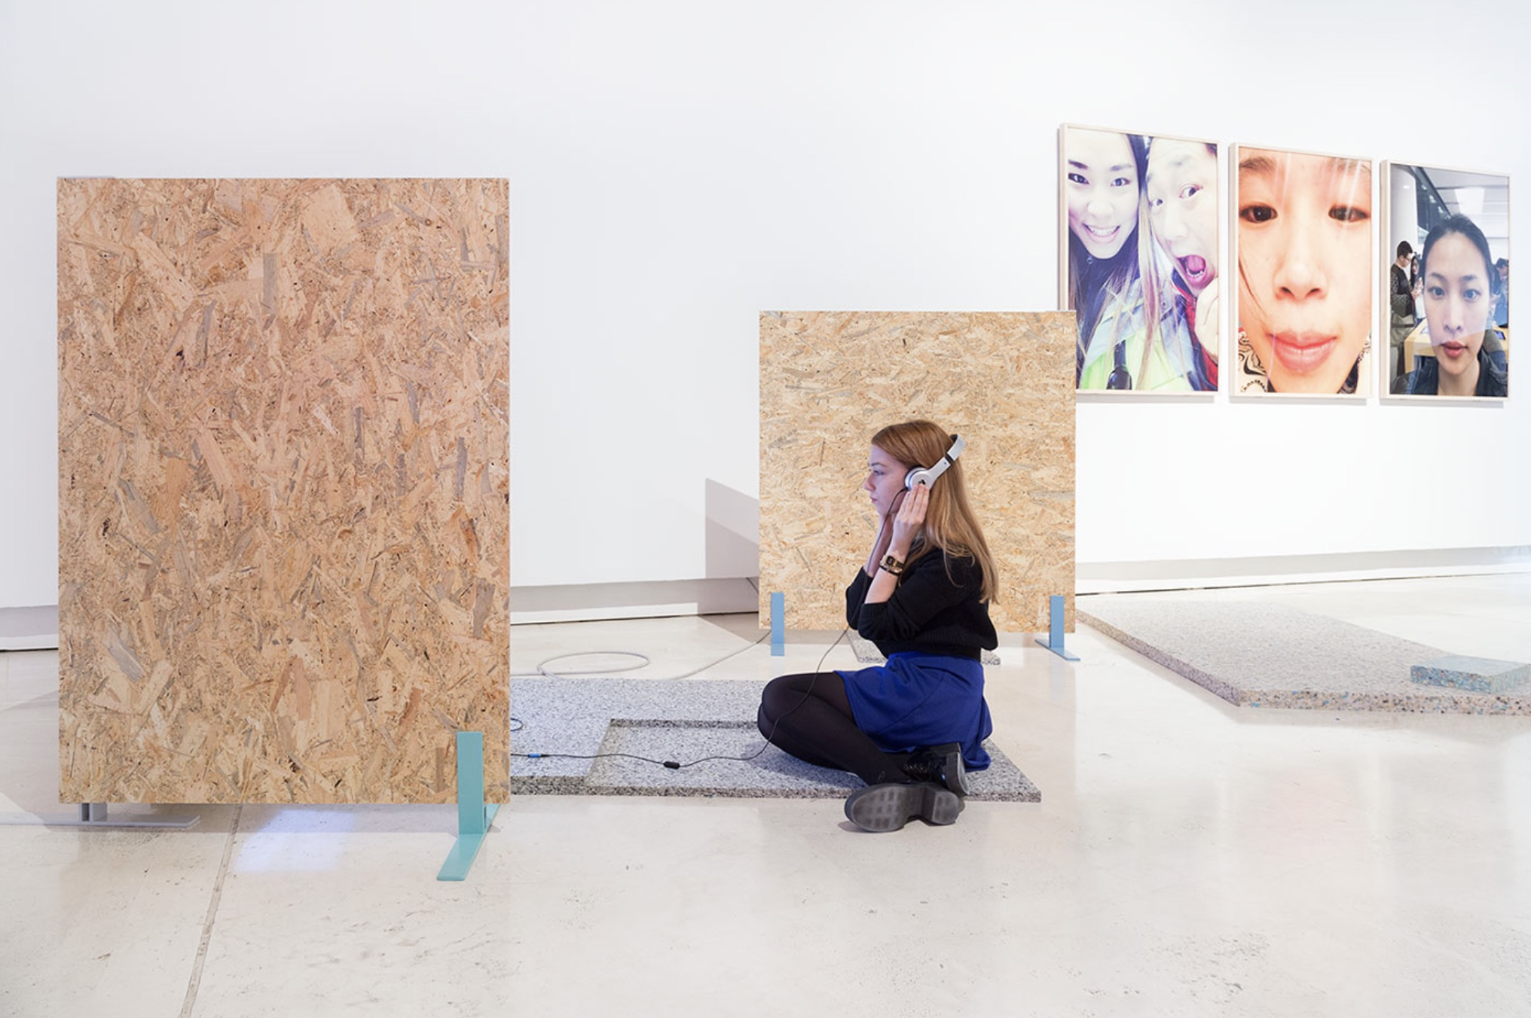

Figure S5. 11: Technologies of Care ©elisagiardinapapa.org.

*Algorithmic Justice League in the movement towards equitable and accountable AI* is a projected initiated in 2016 by Joy Buolamwini, a digital artist activist based at MIT Media Lab.[98] The movement aims to raise awareness of the impact of AI, equip advocates for empirical research, build the voices and choices of the most affected communities, and encourage researchers, policymakers, and industry practitioners to mitigate the harms and especially the biases of AI. The project activity has striven to build a movement to move the AI ecosystem to AI equitably and responsibly.

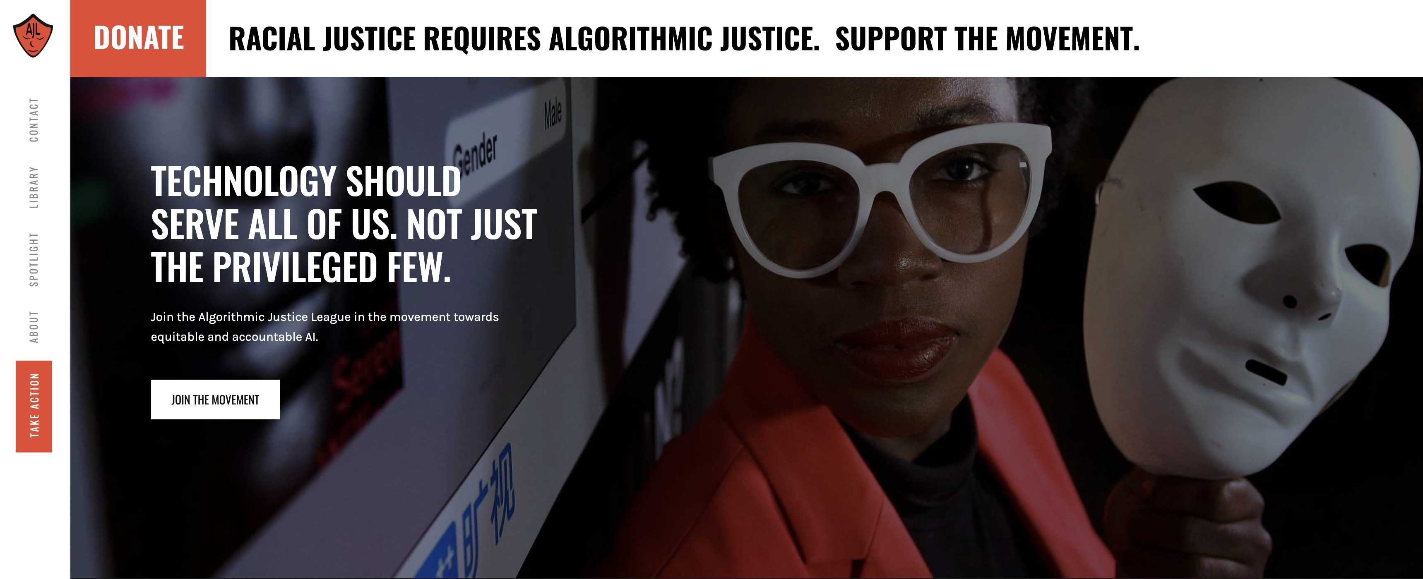

Figure S5. 12: Algorithmic Justice League in the movement towards equitable and accountable AI ©ajl.org.

Joy Buolamwini also created several artworks related to AI and exhibited at *The Criminal Type* (2019) Exhibition at APEXART, New York, NY, US; *Understanding AI* (2019) Exhibition at Ars Electronica Center, Linz, Austria; *AI: More than Human* (2019) Exhibition at the Barbican Centre, London, UK. [99], [100], [101] Buolamwini is one of the most active contemporary artists in AI-related matters.

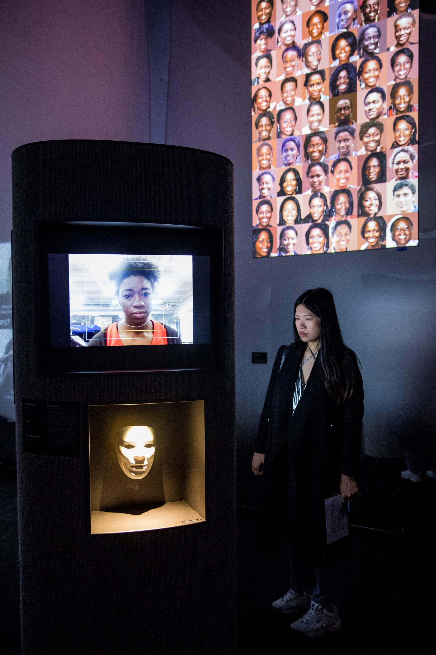

Figure S5. 13: AI Ain't I A Woman, Joy Buolamwini. Courtesy of The Barbican ©dazeddigital.com.

Several art projects use algorithms to *hack* existing problems related to AI technology. This concept of *hacking* was first introduced by Francis Hunger in his article, *How to Hack Artificial Intelligence;* by Janelle Shane in *Do Neural Nets Dream of Electric Sheep?*; and by James Bridle in *Autonomous Trap and Perturbation*; and by a group of artists, including Weili Han, Zhe Zhou, Di Tang, Xiaofeng Wang, Xiangyu Liu, and Kehuan Zhang in *Invisible Mask: Practical Attacks on Face Recognition with Infrared.*[102], [103], [104], [105] All these projects have demonstrated the diverse approach of artists to the technological gaps, limitations of AI applications, and visual and auditory pattern recognition problems of current technology.

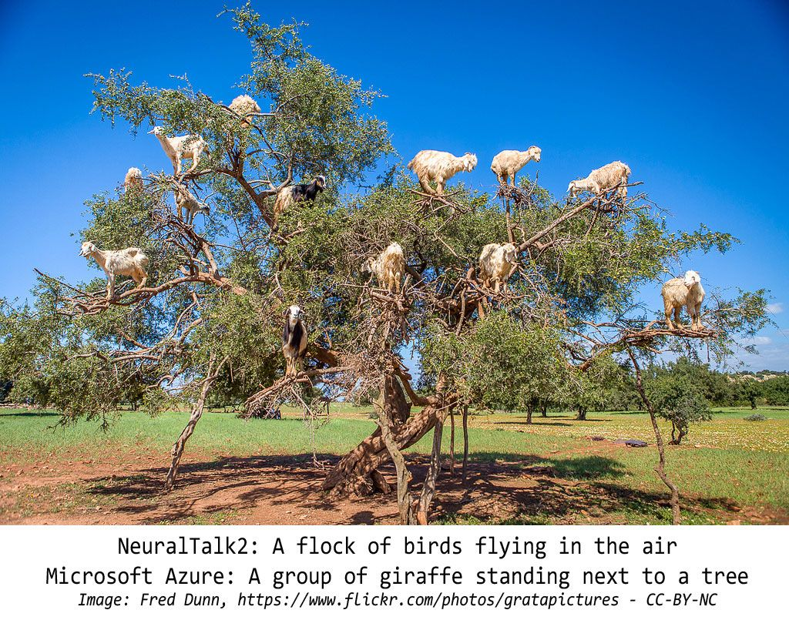

Figure S5. 14: Do Neural Nets Dream of Electric Sheep? by Janelle Shane ©aiweirdness.com.

*This is the Future* by the filmmaker and writer Hito Steyerl at the Portland Art Museum, Oregon, USA (Feb–Jun 2023).[106] This exhibition introduced an imagined garden through an immersive environment of video projection, sculpture, and spatial intervention. Steyerl is one of the foremost artists offering critical reflections on the complexities of the digital world, global capitalism, and the implications of artificial intelligence for society, all reflected sharply in this exhibition.

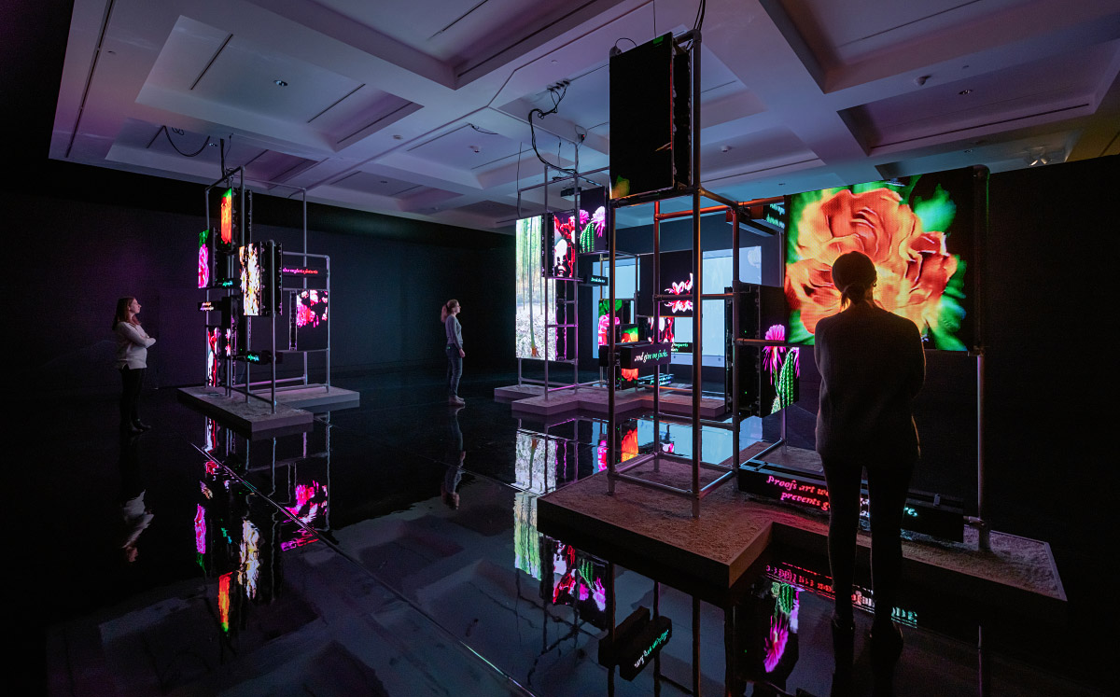

Figure S5. 15: Power Plants, Andrew Kreps Gallery, New York and Esther Schipper, Berlin. ©Hito Steyerl.

Also reflecting on data mining issues, Jennifer Lyn Morone, a London based conceptual artist and designer established a fictitious company to store, buy and sell her own data. She turned herself into a corporation and brought together marketable goods and services. All of her biometric and intellectual data, or things she does such as learning, or creating, became the potential profit. Jennifer Lyn Morone™ Inc began as a graduation project in Design Interactions that created an assumption for a society, namely that we reclaim our digital selves when we take more responsibility for what we are in the digital space. [107], [108]

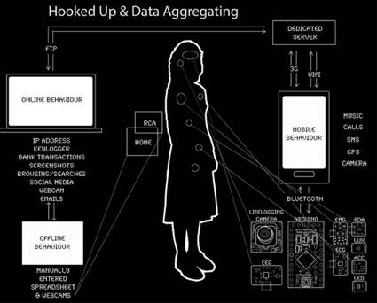

Figure S5. 16: Jennifer Lyn Morone™ ©Jennifer Lyn Morone™ Inc.

*Collectivize Facebook* is one of the social projects ongoing from 2020, proposed by Jonas Staal–a Dutch artist working together with the Belgian lawyer, Jan Fermon.*[109]* It consists of a class action lawsuit aimed at forcing Facebook to be recognized by law as a public domain owned and controlled by users. The project is composed of an indictment against Facebook, which demands that Facebook be recognized as a public domain and the ownership model of Facebook be transferred to its 3 billion users.[110] The lawsuit does not aim to reform Facebook or nationalize it. Its purpose is to turn Facebook into a transnational cooperative under the common ownership and management of the users. Through *pre-trials* (preliminary tribunals) in theaters, cultural spaces, and online platforms, Staal and Fermon engage the public in a debate of the accusation and invite them to participate as co-complainants before filing the indictment at the United Nations Human Rights Court in Geneva. These trials also involve *witnesses of the future* testifying on how to manage a Facebook of three billion co-owners should the case be successful.*[111]*

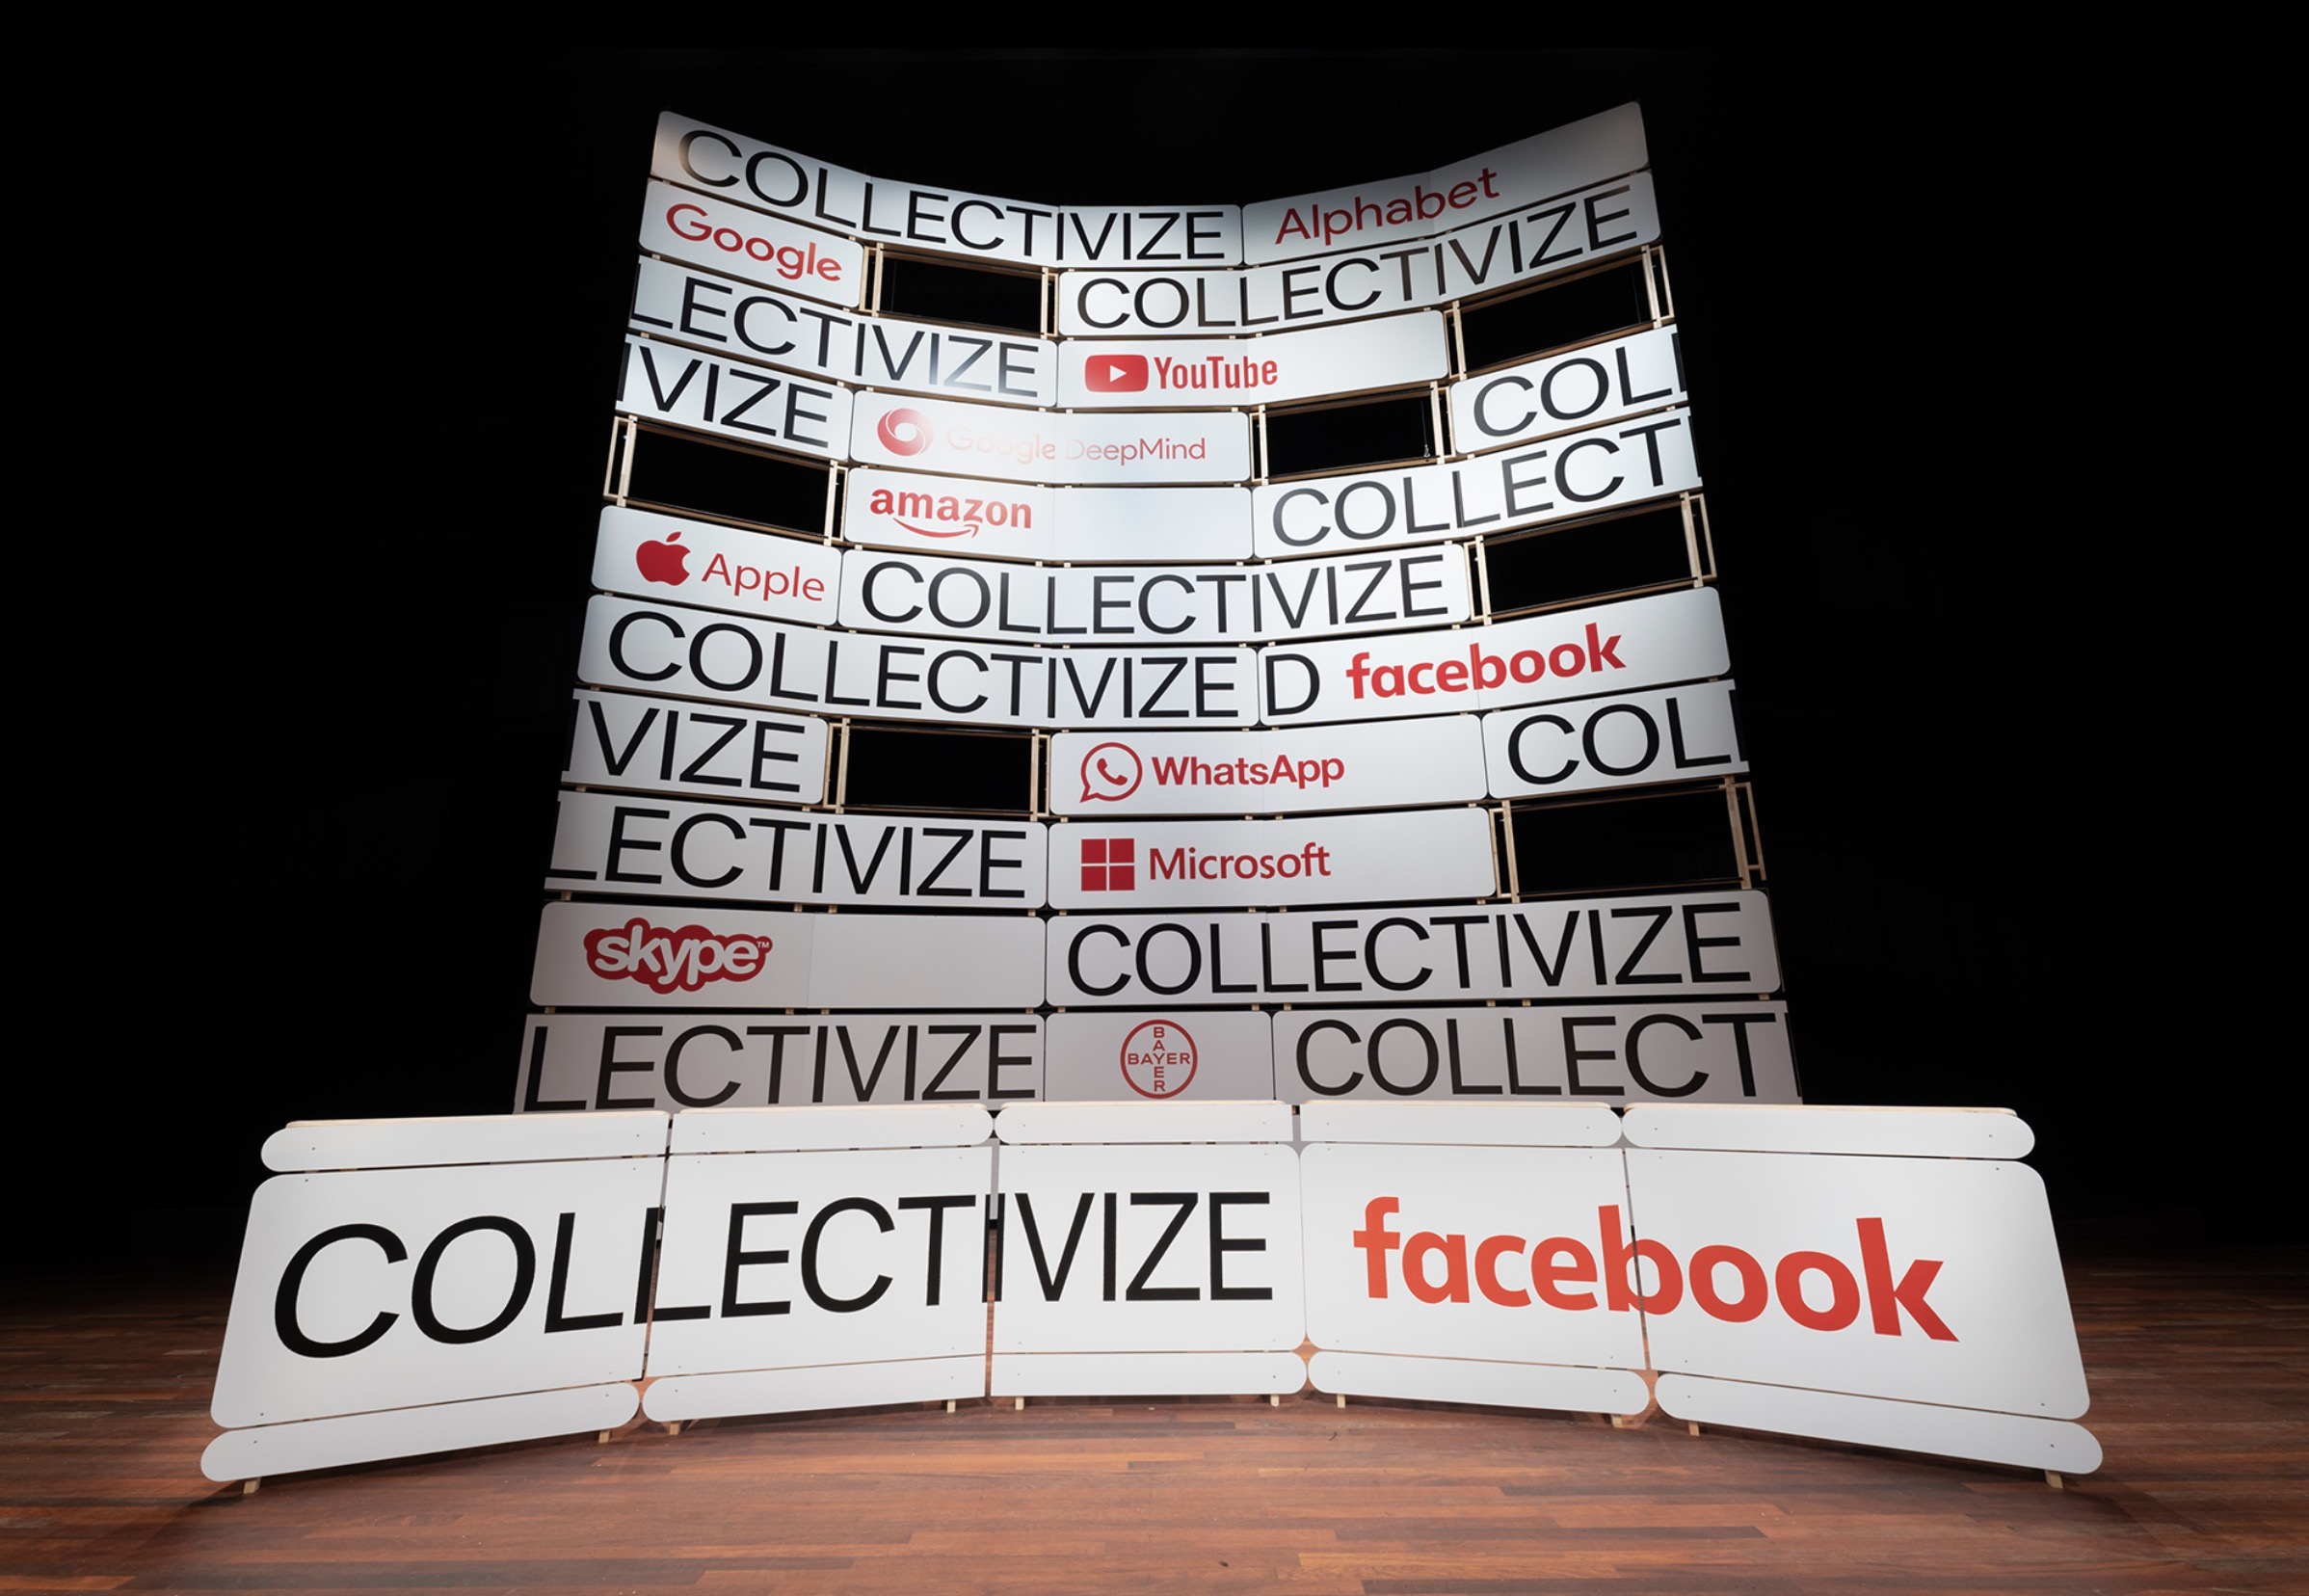

Figure S5. 17: Collectivize Facebook ©jonasstaal.nl.

*Collectivize Facebook* is one of the very few contemporary art projects that offers a concrete and professionally conceived social solution to the issue of human rights in cyberspace. Focused on bringing innovative solutions and ideas to life, indeed, Staal and Fermon have designed a new social model that adapts to the development of technology and serves the benefit of the community. Since it has not been completed it is hard to predict the outcome. It is clearly articulated and impressive hypothesis—apturing the interest of society and confirming the potential and profound impact of art on everyday lives.

Within the art world, we now witness a new wave of interest in AI and the social phenomena surrounding it. Several art forums and seminars with in-depth international discussions on the issue have already been held, such as *Speculative Futures online symposium: Artificial Intelligence* Vancouver Art Gallery, University of British Columbia (UBC), 2022 or *Futures Of Control: Ai In Criminal Investigation*, Mozfest X Impakt - Curated by Rosa Wevers, 2022.[112], [113]

Several important art events related to the theme have also been held in the last three years. Among them are *Brave New Virtues - Shaping Our Digital World,* Vienna Biennale, Austria, 2019; *Uncanny Valley: Being Human in the Age of AI*, Fine Arts Museums of San Francisco, USA 2020-2021; *You and AI: Through the Algorithmic Lens*, Onassis Culture, Athens, Greek, 2021; *Seeing Stones and Spaces Beyond the Valley* Biennale Warszawa, Poland, 2022.[114], [115], [116], [117]

Between 2018 and 2022, as a seasoned artist and designer, I also developed a collection of media artworks that tackle the burgeoning issues within the advertising sector brought on by AI and automation. These pieces expose the covert strategies of surveillance capitalism and cyber colonialism, portraying the complex societal challenges posed by pervasive digital technologies. Additionally, they propose potential solutions for navigating this landscape in the future. Here are some highlighted works.

01. *Brave New Chapter* – Tra Nguyen -Readymades - digital print, collage, size: A0 - Première exhibition: Europa Garage, 5un7 Gallery, Bordeaux (FR), 2019.

Focusing on the transformation of colonialism in the digital age, the project explores the reconstruction of the colonial relationship in cyberspace. By reusing, overlapping and manipulating their posters, the work refers on two connected historical events: the Paris Colonial Exposition (1931) and its critical counter exhibition, The Truth on the Colonies organized by the French Communist Party in the same year.

**

Figure S5. 18: Brave New Chapter ©Tra Nguyen

02. *Dialectic of Cyber-Enlightenment*– Tra Nguyen –Readymades, found object, intervention

size: 45 × 600 cm – Première exhibition: Colonial Warehouse, Archives Bordeaux Metropole, France, 2020.

The work reflects on the transforming and changing structures of contemporary culture in which the developments of cyber-culture are constantly revealing the inherent limitations alongside new conflicts. Inside the scroll book, one can find manipulated quotes of a well-known philosophical thesis written by the Frankfurt School philosophers Max Horkheimer and Theodor W. Adorno – *Dialectic of Enlightenment* (1944). The major part of the citations comes from the chapter *The Culture Industry: Enlightenment as Mass Deception,* a clear depiction of the corporation dominancy, and of the political and economic interests behind, that can be applied to the contemporary cyber-culture as well. The work was inspired by the context of the exhibition – the Archives Bordeaux Métropole – where numerous important historical documents are conserved. The form of this work is reminiscent of a classic scroll book, through which the aim was to record a social phenomenon of our times. The book was made up of technical elements of toner cartridges, and a transparent foil of the retro overhead projectors.



Figure S5. : Dialectic of Cyber-Enlightenment. Courtesy of Szabolcs KissPál

03. *Ring the Bell*– Tra Nguyen -Radio, installation, 2022, with the contribution of Rick Fendrick

Dial phone, audio, duration: 20 minutes,Première: Crack, Artus Studio, Budapest, Hungary, 2022.

The piece reenacts a popular American radio show, *The story behind the headlines* (1930s-1940s) in order to analyze some of the controversial recent media news related to surveillance capitalism. The work pays tribute to the very first telephone newspaper service in the world, the Telefon Hírmondó (Telephone Herald) launched in Budapest in 1893 by the Hungarian Tivadar Puskás. The critical narration referring among others to the American whistleblower Edward Snowden interprets and analyses in a popular language the various public statements of CEO of leading tech giants, such as Mark Zuckerberg (Facebook/Meta), Jeff Bezos (Amazon), Satya Nadella (Microsoft), Sundar Pichai (Alphabet/Google), Tim Cook (Apple) or Elon Musk (Neurolink, OpenAi). Explore the work using this link: https://tranguyen.net/portfolio/ring-the-bell.

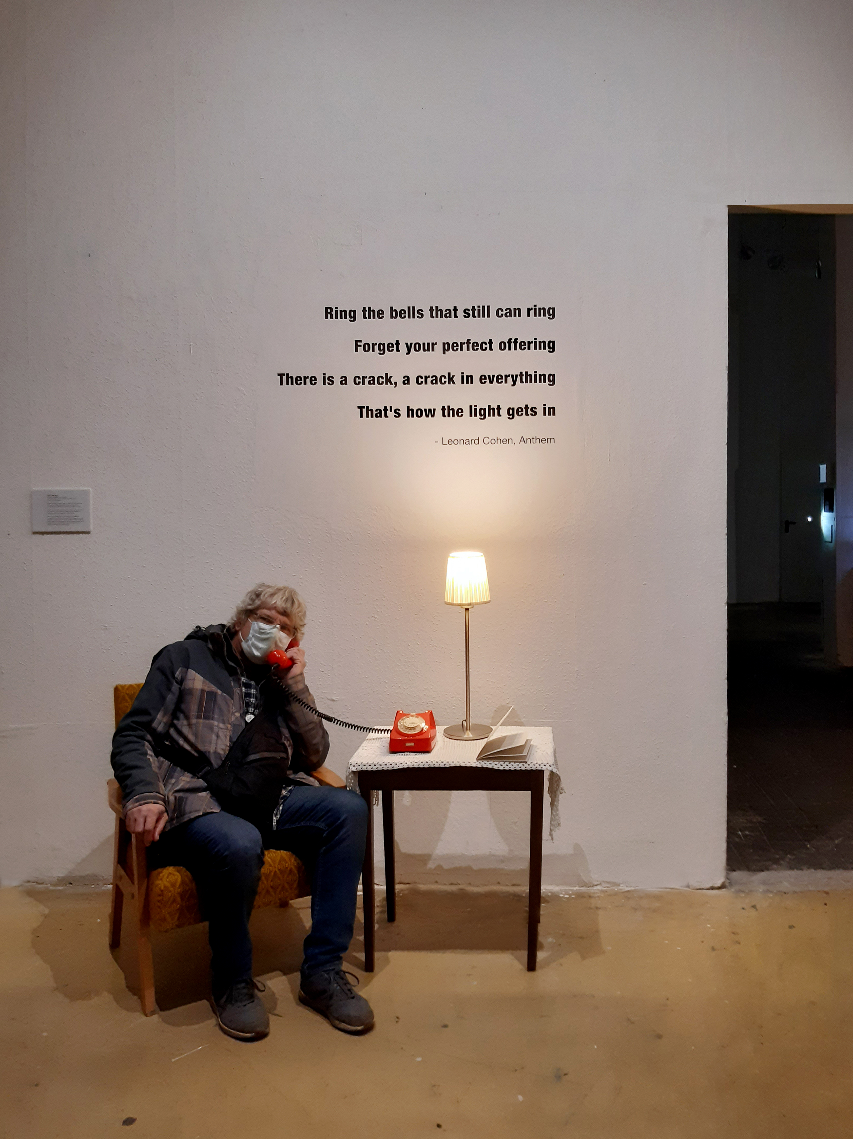

Figure S5. 20: Ring the Bell. Courtesy of Andrea Bánóczy Varga.

04. *Systematic Error* - Tra Nguyen –Installation - Antique ICA photo camera, scale, batteries, text, dimensions: 600 × 200 cm, Première: Crack, Artus Studio, Budapest, Hungary, 2022.

The installation refers to the dystopian character of the social credit system relying on personal data harvesting and analysis by AI algorithms in order to control the population. The complex evaluation mechanism of citizens is already fully operational, for example, in China. Surprisingly enough, among thousands of features used to evaluate the individuals, the delinquency rate (applied in the risk management of banks) is closely related to the battery charge level of personal mobile devices. The regular low battery level information results in a high delinquency rate classification of a person by the man-made algorithm system. When one’s battery is often low, that does not necessarily mean carelessness, unreliability, or poverty; there could be many other reasons behind it. For example, an environmental consideration: the quantity of battery usage is strongly connected with the cobalt mining problem. The global demand for the ingredient of lithium-ion batteries causes significant social disasters in countries like Congo. That’s why an *algorithmic error* of a faulty social system can generate various wrong consequences.



Figure S5. 21: Systematic Error ©Tra Nguyen.

05. *Data Hot Pot*– Tra Nguyen -Zine contribution, Print, size: 60 × 60 cm, pages 44-47, Première: Contemporary Cosmopolitan Cookbook, pages 44-47, HUFA, Budapest, Hungary, 2021.

Published as a zine contribution in the online publication *Contemporary Cosmopolitan Cookbook*- a joint project of Fine Art Theory students and the SH-DLA students from the Hungarian University of Fine Arts. The conceptual recipe of a well-known Vietnamese dish, *the hot pot*, is being adapted to the phenomenon of online data consuming. The tension of this parallel lies in the fact that while hot pot meals are characterized by a collective generosity of sharing common resources, the global hot pot of online data redistribution is rather biased, and highly unfair.

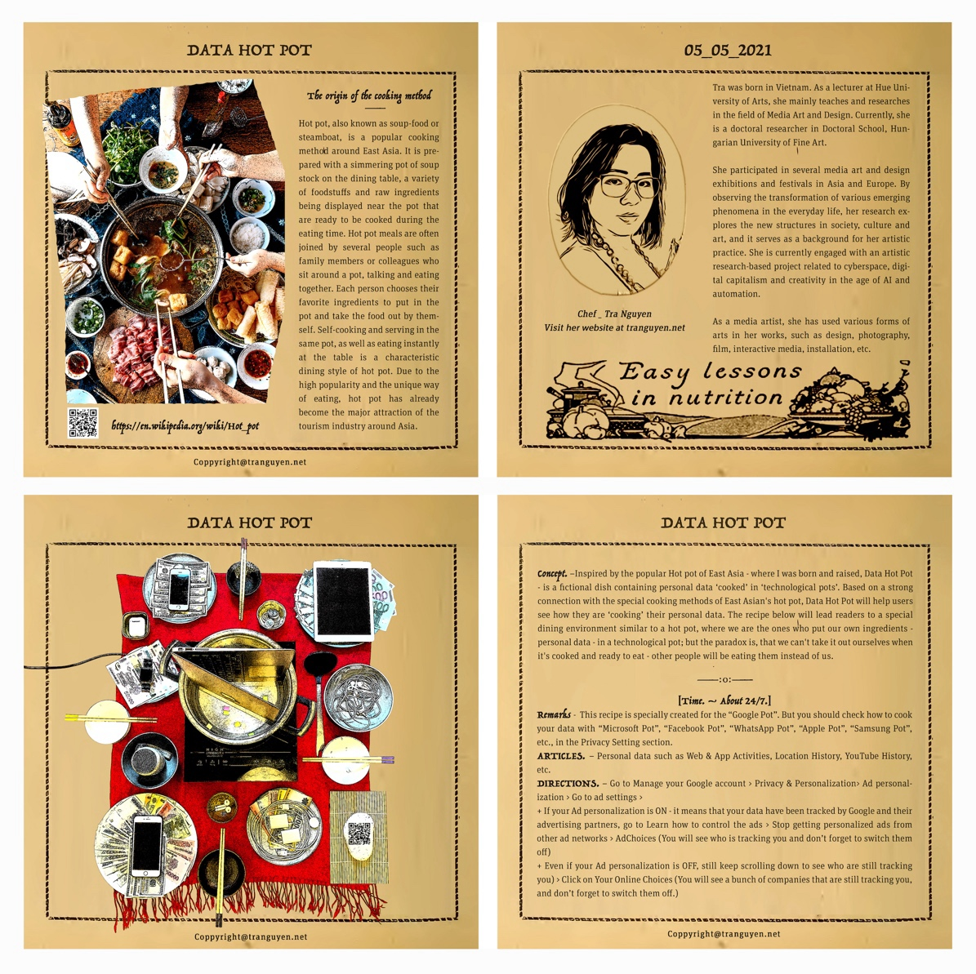

Figure S5. 22: Data Hot Pot ©Tra Nguyen.

06. *Parallel Predictions*– Tra Nguyen –Installation, 12 found objects, 12 tarot-cards, Première: Parallel Hungary II, Profil Gallery, Budapest, Hungary, 2022.

The artwork creates a miniature space - introducing 12 ancient forms of fortune telling, creating a connection between the traditional and contemporary prediction practices. Predicting the future has been a sort of cultural practice related to everyday living in various cultures. They all conduct predictions as an attempt to find the future, from Greek oracles to prophets of diverse religions; from African priestesses performing ritual ceremonies to Asian monks in Buddhist temples. Predictions can aim at both large social issues and specific personal issues. Many of these activities are still used today. Furthermore, numerous traditional forms of divination and fortune-telling have also been turned into digital applications. While the majority of historical fortune-telling practices rely on the interpretation of randomness in natural patterns, shapes, forms, or occurrences, these applications work rather differently. They have another tactical intention; to collect user data for a completely different prediction purpose – that control interest, manipulate imagination, and limit randomness. Giant servers employ personal data mining to collect demographic and psychographic information about users in order to track their personal intentions and predict their interests in order to meet future demand. This is capitalism's main source of *energy* for making predictions and creating specific future scenarios for users, thus serving the interests of enterprises, corporations, or groups.

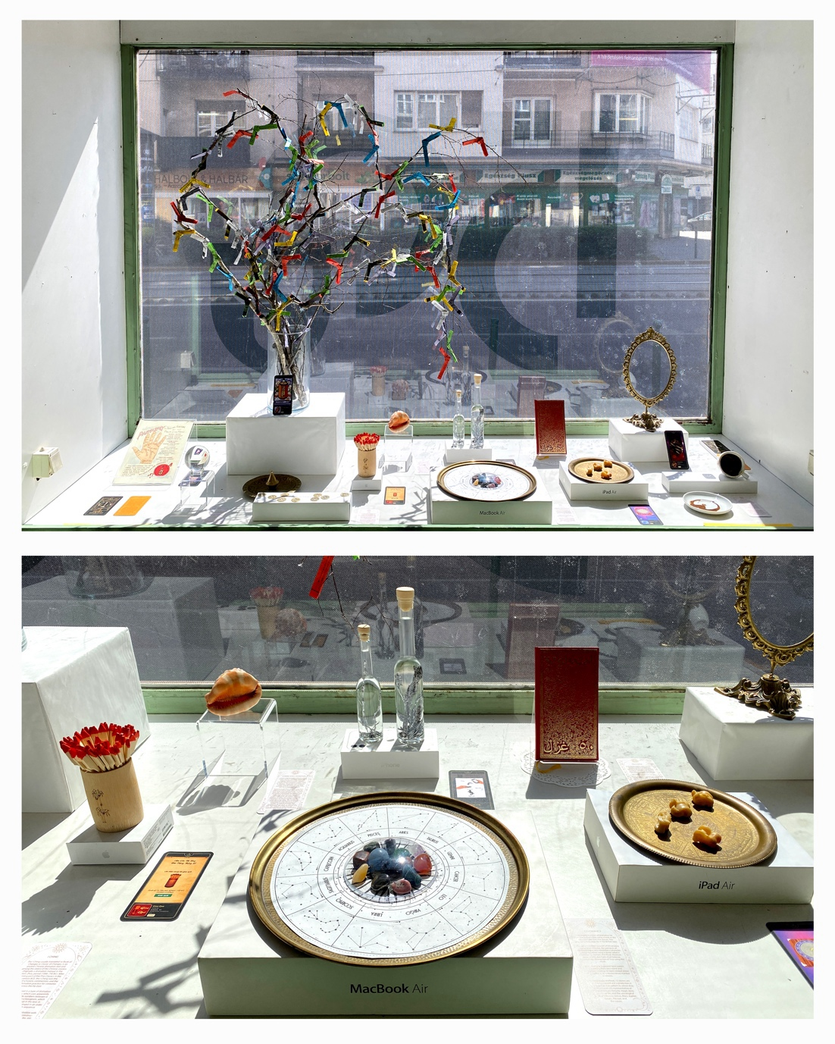

Figure S5. 23: Parallel Predictions ©Tra Nguyen.

07. *Horus* Case – Tra Nguyen -Cyber performance, docufiction, Virtual exhibition space, webpage, e-book, video, duration: 2 minutes, Première: Host and hostility, HUFA-online, Hungary, 2020.

Horus Case is a cyber performance based on a fictional scenario. The video is a war declaration to the Union of Corporations and States (UCS) by Anonymous–a decentralized, international hacktivist collective. In this the atrocities of UCS are disclosed, and the top-secret document, *Cyber Interrogation and Torture Manual*, of the UCS is revealed. The piece refers to the lockdown situation during the COVID-19 pandemic, when personal life was more intensely influenced by the cyber world. The oversaturation with information, the threat of the news about deadly infectious diseases, and the overload of online working and communication generated terrible claustrophobia and crazy suppression around the world. The COVID-19 situation brought many of us to the state of feeling subjected to a real cyber-psychological torture.

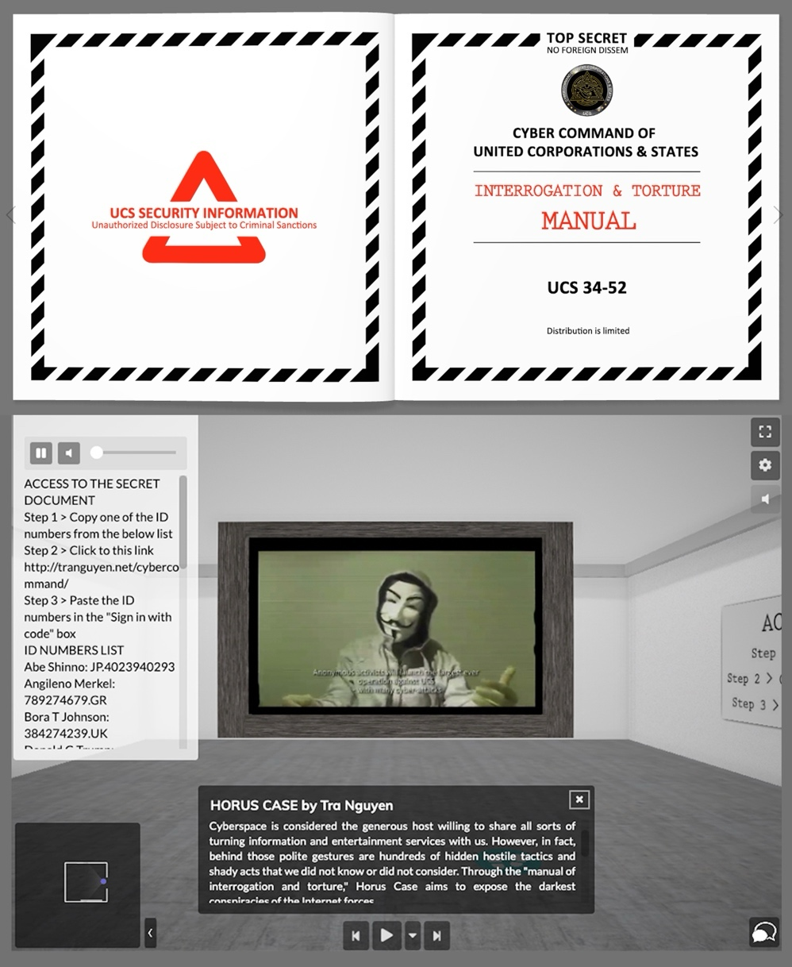

Figure S5. : Horus Case ©Tra Nguyen.

08. *Edward’s Trash Bin*– Tra Nguyen –Readymades, Found object, removed camera and microphone, dimensions: 2 × 3 cm, Première: Crack, Artus Studio, Budapest, Hungary, 2022.

Edward Joseph Snowden (1983) is an American former computer intelligence consultant and president of the Freedom of Press Foundation, who as a whistleblower leaked highly classified information from the National Security Agency (NSA) in 2013, shedding light on the global surveillance apparatus of the institution. The American authorities have condemned his act, and he had to flee in exile because of the criminal charges brought up against him. In one of his interviews (MSNBC, *The 11th Hour*, 9/17/2019) he disclosed that the recording capacity of a smart phone is operational even when the device is powered off, therefore he always removes the inbuilt camera and mic from his own devices, in order to ‘being able to trust our technology’ again.

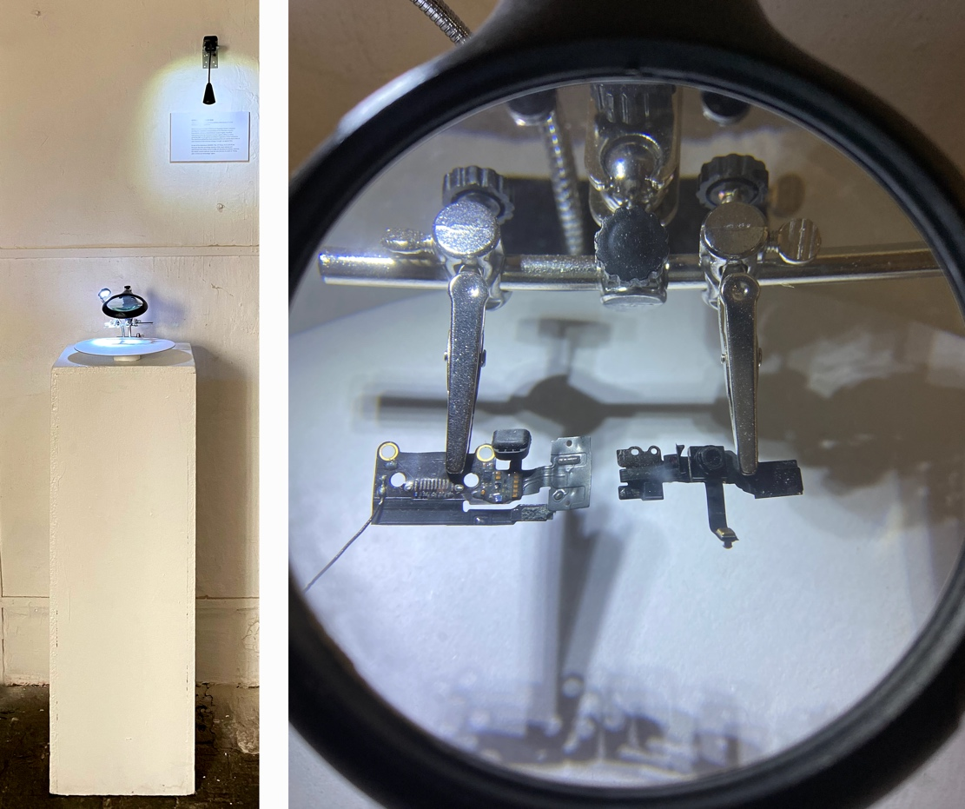

Figure S5. 25: Edward’s Trash Bin ©Tra Nguyen.

09. *The Keys*– Tra Nguyen –Installation, info graphics, digital print, plexiglass, dimensions: 68 × 68 × 500 cm, Première: Parallel Hungary, Aula HUFA Budapest, 2020.

The piece – based on personal experiences – depicts how the strangers visualize and conceptualize the Hungarian culture, people, politics. What are their first impressions, what information are they more interested in, which images become representative symbols? The answers on all these questions seem obvious through the statistics shown by search engines. Nonetheless, the discrepancy between the filtered, manipulated information of the internet statistics and the real impressions of a Vietnamese person is the central concept of the work.



Figure S5. 26: The Keys ©Tra Nguyen.

10. *Cyber-colonialism*– Tra Nguyen -performative lecture, video, duration: 13 minutes, Première: Bucharest Biennial (RO), 2021.

The performance enacts a traditional Vietnamese storyteller who shared her concerns and warnings on data privacy with her villagers while outlining the short history of how technology and colonialism have been tied together throughout the centuries. The tone of the narration intentionally fluctuates between an academic presentation and an entertaining fable. The work was inspired by an actual elderly storyteller image in Vietnam *(The elderly story teller – Bà… in Ta Oi, Hue, Vietnam);* even today, a female village leader still circulates traditional stories, telling legends to the people of her village every night.*[118]* Collective awareness and memory formed through oral retelling is the most primitive form of human communication, and it remains a precious and important form of social communication in some places.

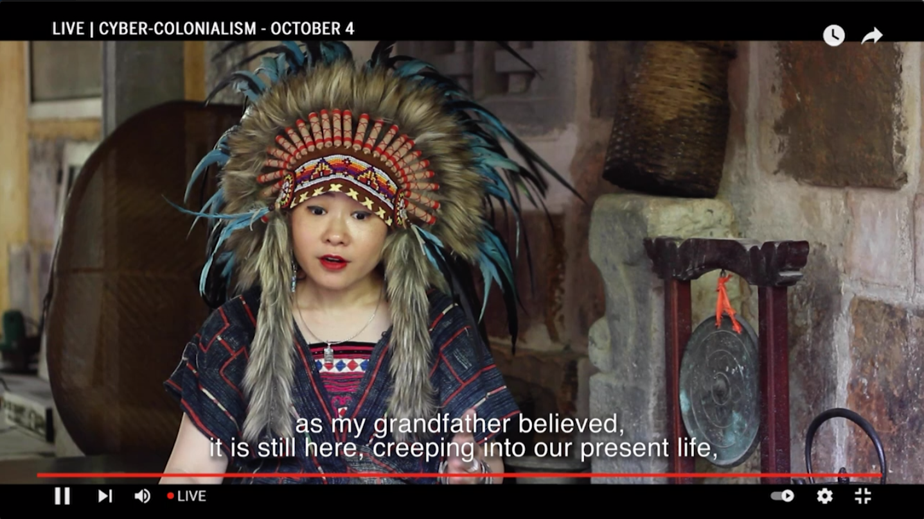

Figure S5. 27: Cyber-colonialism ©Tra Nguyen

11. *Protect21* – Decolonizing Cyberspace– Tra Nguyen -42 posters, digital print, various authors, various sizes, & Introductory video - duration: 10 minutes, Première: Bucharest Biennial 2021.

This campaign entitled *Wiping Digital Footprint* is part of the *Protect21*, a wider social design project that aims to contribute to solving several prominent life issues recognized in the early decades of the 21st century: the threats of the digital world and new technology, the issues of urban environment and food safety, primarily focusing on Vietnam. Initiated by artist and designer Tra Nguyen in early 2021, the project’s activities are largely based on the support of the media art language that through creative cultural campaigns contribute to raising public awareness, to changing everyday habits and inspiring new behaviors for a better and more sustainable life. Project’s website: https://protect21.net/?lang=en.



Figure S5. 28: Protect21 – Decolonizing Cyberspace ©Tra Nguyen.

Contemporary discussions, projects, artworks, and designs have contributed positively to raising social awareness and proposing solutions related to new social phenomena. In the flow of art and design, advertising design is also a powerful tool to confront the new problems created by the AI advertising technology itself. In previous sections of this study, one notes the tremendous economic benefits that the advertising industry provided. In an influencing position, if the design, production, and distribution of advertising aim at the true social benefits, it might generate improved scenarios for the future of our society. James Walter Thompson (1847—1928) stated that ‘Advertising is a non-moral force like electricity which not only illuminates but also electrocutes. In fact, its worth to civilization depends upon how it is used’.[119]

In addition to the classic design tools (such as graphic activist works), we need new forms of design (such as video, interactive, and display or mobile ads) to participate in social media campaigns, human rights and equality movements in cyberspace. Combined with live protests, posters, brochures, and flyers spread around the streets, we may also need to develop hacking methods on the internet or use programmatic advertising modes for propaganda campaigns to fight against the meta forces. Even without identifying themselves as socially engaged design, the mentioned art projects and activist movements have more or less included the resistance design methods to which this study refers.

All in all, socially engaged design practice will soon become an international contemporary design action. This practical approach aims mainly at sustainable benefits for society. In the flow of socially engaged design, advertising design is a potential practice to record, impress, and generate solutions. Changing the function of design to minimize harm and increase its positive impact has become an urgent task to consider in our contemporary society.

**References**

Barlow, John Perry. ‘A Declaration of the Independence of Cyberspace.’ Davos, Switzerland, February 8, 1996. https://www.eff.org.

Baudrillard, Jean. *Simulacra and Simulation*. Translated by Sheila Faria Glaser. Ann Arbor: University of Michigan Press, 1995. ‘On Nihilism,’ 104.

Benjamin, Walter. *The Work of Art in the Age of Mechanical Reproduction*. London: Penguin UK, 2008, 1.

Bowcott, Owen. ‘UN Warns of Rise of 'Cybertorture' to Bypass Physical Ban.’ The Guardian, February 20, 2020.

Britt, Douglas. ‘The Yes Men Infiltrate DiverseWorks.’ *Houston Chronicle*, 2010.

Brown, Abram, and Abigail Freeman. ‘The Highest-Paid YouTube Stars: MrBeast, Jake Paul and Markiplier Score Massive Paydays.’ *Forbes*, 2022. https://www.forbes.com.

Clouds, *Connected: The Hidden Science of Everything*, Docuseries, Netflix, 2020

Coeckelbergh, Mark, M. *AI ethics*. Mit Press. 2020.

Connor, Michael. ‘I Am the World Trade Organization ... Or Am I?’ *Austin Chronicle*, July 5, 2002.

Curtis, Adam. ‘Interview about the Documentary Film HyperNormalisation.’ Interviewed on October 16, 2016.

Davie, Michael. ‘Blood Cobalt.’ *ABC News*, 2022. https://abc.net.au.

Debord, Guy. ‘Internationale Situationist.’ *Internationale Situationist*, no. 1 (Paris), June 1958.

Doyle, Charles. *A Dictionary of Marketing*. Oxford University Press, 2016.

Dubber, Markus D., Frank Pasquale, and Sunit Das, eds. *The Oxford Handbook of Ethics of AI*. Oxford: Oxford University Press, 2020.

Dyer-Witheford, Nick, Atle Mikkola Kjøsen, and James Steinhoff. *Inhuman Power: Artificial Intelligence and the Future of Capitalism*. London: Pluto Press, 2019.

Farrant, Theo, and AFP. ‘From Lawsuits to Tech Hacks: Here's How Artists Are Fighting Back Against AI Image Generation.’ *Euronews*, 2023.

Fisher, Mark. *Capitalist Realism: Is There No Alternative?* Winchester, UK: John Hunt Publishing, 2022.

Flanders, Laura. ‘At Thatcher's Funeral, Bury TINA, Too.’ *The Nation*, 2013.

Foer, Franklin. ‘Click ‘Delete’ to Save Your Soul.’ *The New York Times*, 13 June, 2018.

Fuad-Luke, Alastair. *Design activism: beautiful strangeness for a sustainable world*. Routledge, 2013.

Garrett, Marc. ‘Reclaiming The Corporate-Owned Self.’ In *State Machines: Reflections and Actions at the Edge of Digital Citizenship, Finance, and Art*. Institute of Network Cultures, 2019.

Gauri, Pratik. ‘What the Fifth Industrial Revolution Is and Why It Matters.’ *World Economic Forum*, 2019.

Harari, Yuval Noah. ‘Lessons from a Year of Covid.’ *Financial Times*, 2021.

Harari, Yuval Noah. ‘The World After Coronavirus.’ *Financial Times*, March 20, 2020.

Heidegger, Martin. *The Question Concerning Technology*. New York and London: Garland Publishing, Inc., 1977.

Hempel, Jessi. ‘Fei-Fei Li's Quest to Make Machines Better for Humanity.’ *Wired*, 2018. ISSN 1059-1028. https://www.wired.com.

Howard, Philip N., Aiden Duffy, Deen Freelon, Muzammil M. Hussain, Will Mari, and Marwa Maziad. ‘Opening Closed Regimes: What Was the Role of Social Media during the Arab Spring?’ *SSRN*, 2011.

Hunger, F. ‘How to Hack Artificial Intelligence.’ In *State Machines: Reflections and Actions at the Edge of Digital Citizenship, Finance, and Art*. Institute of Network Cultures, 2019.

James Bridle, ‘Autonomous Trap 001’, *James Bridle*, 2017,

Janelle Shane, ‘Do Neural Nets Dream of Electric Sheep?’, *AI Weirdness Blog*,

Kuhn, Thomas S. ‘Book and Film Reviews: Revolutionary View of the History of Science: The Structure of Scientific Revolutions.’ *The Physics Teacher* 8, no. 2 (1970), p. 96-98.

Laczko, Jozsef. *The Art of Hacking*. Budapest: The Hungarian University of Fine Arts Publisher, 2021. ISBN 978-963-9990-95-1.

Lanier, Jaron. *Ten Arguments for Deleting Your Social Media Accounts Right Now*. New York: Random House, 2018.

Lanier, Jaron. *Who Owns the Future?* New York: Simon and Schuster, 2014.

Lovink, Geert. *Dark Fiber: Tracking Critical Internet Culture*. Cambridge, MA: MIT Press, 2003.

Lynch, Marc. ‘Twitter Devolutions.’ *Foreign Policy*, no. 7, 2013.

Malone, Thomas W. *Superminds: How Hyperconnectivity Is Changing the Way We Solve Problems*. New York: Simon and Schuster, 2018.

Margolin, Victor. ‘Design for a Sustainable World.’ *Design Issues* 14, no. 2 (1998): 83-92.

Monsees, L. Cryptoparties: empowerment in internet security?. *Internet Policy Review*, 2020, *9*(4), 1-19.

OECD Science, *Technology and Industry Scoreboard*. OECD. 2015. p. 156.

Pasanno, Ajahn, and Ajahn Amaro. ‘Knowing, Emptiness and the Radiant Mind.’ *Forest Sangha Newsletter* 88 (2009): 5. https://forestsangha.org.

Pasquale, Frank. *The Black Box Society: The Secret Algorithms That Control Money and Information*. Cambridge, MA: Harvard University Press, 2015.

Perrigo, Billy. ‘Elon Musk Signs Open Letter Urging AI Labs to Pump the Brakes.’ *Time*, March 29, 2023.

Reesearch Team of the Studio for Designing Interactive Spaces and Objects. *Signs of Empathy in Contemporary Design*. Wroclaw, Poland: The Eugeniusz Geppert Academy of Art and Design, 2023. ISBN 978-83-66321-78-6.

Reynolds, Simon. ‘Mark Fisher's K-punk Blogs Were Required Reading for a Generation.’ *The Guardian*, 2017.

Robinson, Nick. ‘Economy: There is no alternative (TINA) is back’. *bbc.com. BBC News*, 2023.

Srnicek, N. We need to nationalise Google, Facebook and Amazon. Here’s why, *The Guardian,* 2017.

Thanh Thương. ‘Livestream Bán Hàng Lậu Thu Chục Tỷ Mỗi Tháng.’ *Tạp Chí Tri Thức*, 2020.

Theo Farrant & AFP, From lawsuits to tech hacks: Here's how artists are fighting back against AI image generation, *Euronews,* 2023.

Thy An. ‘Livestream trên Thương Mại Điện Tử - Nghề Hot của Giới Trẻ.’ *VnExpress*, 2021.

Triscott, Nicola. ‘Interfaces of Performance.’ In *Interfaces of Performance*, edited by Maria Chatzichristodoulou, Janis Jefferies, and Rachel Zerihan, 209-221. Surrey: Ashgate Publishing Limited, 2009.

Turner, Luke. ‘Metamodernist Manifesto.’ *Metamodernism*, 2011.

Vương Trần. ‘Cho Thôi Giữ Chức Vụ 2 Phó Thủ Tướng, 3 Thứ Trưởng và Tương Đương, 1 Chủ Tịch Tập Đoàn Trong Năm 2022*.’ Lao Động*, 2023.

Webb, A. *The big nine: How the tech titans and their thinking machines could warp humanity*. Hachette UK. 2029.

Weinberger, David. ‘Our Machines Now Have Knowledge We’ll Never Understand.’ *Wired*, April 18, 2017.

Zhong, Yuhao. ‘Rethinking the Social Credit System: A Long Road to Establishing Trust in Chinese Society.’ In *Symposium on Applications of Contextual Integrity*, 28–29, 2019. https://privaci.info.

1. Nick Robinson, ‘Economy: There is no alternative (TINA) is back’. *bbc.com. BBC News*, 2023.
2. Wikipedia contributors, ‘There is no alternative’, 18 November 2020, https://en.wikipedia.org/wiki/There_is_no_alternative#:~:text=%22There%20is%20no%20alternative%22%20(,British%20prime%20minister%20Margaret%20Thatcher.
3. Simon Reynolds, ‘Mark Fisher's K-punk Blogs Were Required Reading for a Generation.’ *The Guardian*, 2017.
4. Laura Flanders, ‘At Thatcher's Funeral, Bury TINA, Too’, *The Nation*, 2013.
5. *A New Philosophy on Artificial Intelligence,* (Kristian Hammond, 2018) TEDx North WesternU, Available at: https://www.youtube.com/watch?v=tr9oe2TZiJw.
6. *A New Philosophy on Artificial Intelligence,* (Kristian Hammond, 2018) TEDx North WesternU, Available at: https://www.youtube.com/watch?v=tr9oe2TZiJw.
7. *How Digital Technologies Are Transforming the Media Industry*, (Miklos Sarvary, 2017), Columbia Business School Available at: https://www.youtube.com/watch?v=QuU8qDVz4gg&t=122s.
8. Kara Anne Swisher - a journalist, who co-founded Vox Media's Recode mentions these ideas in *The Facebook Dilemma*, (Frontline, 2018), Available at: https://www.youtube.com/watch?v=T48KFiHwexM&t=55s.
9. *The keynote of Satya Nadella*, (Microsoft, 2020), https://www.youtube.com/watch?v=0v1vyWJQlzs&t=2101s.
10. *The keynote of Sundar Pichai*, (Google, 2022), https://www.youtube.com/watch?v=nP-nMZpLM1A&t=387s.
11. *The keynote of Tim Cook*, (Apple, 2019), https://www.youtube.com/watch?v=-rAeqN-Q7x4.
12. *Metaverse, How We'll Build It Together,* (Mark Zuckerberg, Meta, 2021), https://www.youtube.com/watch?v=Uvufun6xer8&t=80s.
13. *Google IO 2021 keynote - CEO Sundar Pichai*, (Google, 2020), https://www.youtube.com/watch?v=mMSfUeJ49yk.
14. *Microsoft AI: Empowering Outcomes in the Intelligent Cloud - Satya Nadella,* (Microsoft, 2019),

    https://www.youtube.com/watch?v=yc0Gi0w3ldM.
15. *Metaverse, How We'll Build It Together,* (Mark Zuckerberg, Meta, 2021). https://www.youtube.com/watch?v=Uvufun6xer8&t=80s.
16. The loyalty business model is a business model used in strategic management in which company resources are employed so as to increase the loyalty of customers and other stakeholders. Wikipedia contributors, ‘Loyalty business model’, 8 November 2021. https://en.wikipedia.org/wiki/Loyalty_business_model.
17. Philip N Howard, Aiden Duffy, Deen Freelon, Muzammil M. Hussain, Will Mari and Marwa Maziad, ‘Opening Closed Regimes: What Was the Role of Social Media during the Arab Spring?’ *SSRN*, 2011. https://ssrn.com/abstract=2595096.
18. *The Facebook Dilemma,* (Fronline, 2018), Documentary film. https://www.youtube.com/watch?v=T48KFiHwexM&t=55s.
19. *The Facebook Dilemma,* (Fronline, 2018), Documentary film. https://www.youtube.com/watch?v=T48KFiHwexM&t=55s.
20. Marc Lynch, ‘Twitter Devolutions.’ *Foreign Policy*, no. 7, 2013.
21. An email bomb is a form of net abuse that sends large volumes of email to one address to overflow the mailbox and overwhelm the server where the email address is hosted or as a smoke screen to distract the attention from important email messages.

    Wikipedia contributors, ‘Email bomb’, 8 November 2021. https://en.wikipedia.org/wiki/Email_bomb.
22. Owen Bowcott, ‘UN Warns of Rise of 'Cybertorture' to Bypass Physical Ban.’ *The Guardian*, 21 February 2020. https://www.theguardian.com/law/2020/feb/21/un-rapporteur-warns-of-rise-of-cybertorture-to-bypass-physical-ban.
23. Owen Bowcott, ‘UN Warns of Rise of 'Cybertorture' to Bypass Physical Ban.’ *The Guardian*, 21 February 2020.
24. *The Facebook Dilemma,* (Fronline, 2018), Documentary film. https://www.youtube.com/watch?v=T48KFiHwexM&t=55s.
25. Thy An, ‘Livestream trên Thương Mại Điện Tử - Nghề Hot của Giới Trẻ’, *VnExpress*, 2 October 2021.

    https://vnexpress.net/livestream-tren-thuong-mai-dien-tu-nghe-hot-cua-gioi-tre-4359693.html.
26. *knock-off is* a cheaper copy of an expensive and popular product.

    Dictionary Cambridge, 'knockoff', 2 September 2021, ttps://dictionary.cambridge.org/dictionary/english/knockoff.
27. Thanh Thương, ‘Livestream Bán Hàng Lậu Thu Chục Tỷ Mỗi Tháng.’ *Tạp Chí Tri Thức*, 10 July 2020. https://zingnews.vn/livestream-ban-hang-lau-thu-chuc-ty-moi-thang-post1104703.html.
28. Abram Brown and Abigail Freeman. ‘The Highest-Paid YouTube Stars: MrBeast, Jake Paul and Markiplier Score Massive Paydays.’ *Forbes*, 11 May 2022. https://www.forbes.com.
29. *I Remove This Mysterious Tiny Chip Before Using The Phone!* (Edward Snowden, 2021) Available at: https://www.youtube.com/watch?v=0dGqR4ue8dg&t=1s.
30. David Weinberger, ‘Our Machines Now Have Knowledge We’ll Never Understand.’ *Wired*, 18 April 2017.

    https://www.wired.com/story/our-machines-now-have-knowledge-well-never-understand.
31. The founder, CEO and chief engineer of SpaceX; angel investor, CEO and product architect of Tesla, Inc.; owner and CEO of Twitter, Inc.; founder of the Boring Company; co-founder of Neuralink and OpenAI; and president of the philanthropic Musk Foundation.
32. Billy Perrigo, ‘Elon Musk Signs Open Letter Urging AI Labs to Pump the Brakes.’ *Time*, March, 29 March 2023. https://time.com/6266679/musk-ai-open-letter/#lftvdfup8goooe30kuo.
33. Frank Pasquale, *The Black Box Society: The Secret Algorithms That Control Money and Information*. Cambridge, MA: Harvard University Press, 2015. p.3.
34. Martin Heidegger, *The Question Concerning Technology*. New York and London: Garland Publishing, Inc., 1977.
35. Martin Heidegger, *The Question Concerning Technology*. New York and London: Garland Publishing, Inc., 1977.
36. OECD Science, *Technology and Industry Scoreboard*. OECD. 2015. p. 156.

    https://www.oecd-ilibrary.org/science-and-technology/oecd-science-technology-and-industry-scoreboard-2015_sti_scoreboard-2015-en.
37. Thomas S Kuhn, ‘Book and Film Reviews: Revolutionary View of the History of Science: The Structure of Scientific Revolutions.’ *The Physics Teacher* 8, no. 2 (1970), p. 96-98.
38. Yuval Noah Harari, ‘Lessons from a Year of Covid.’ *Financial Times*, 2021.

    https://www.ft.com/content/f1b30f2c-84aa-4595-84f2-7816796d6841.
39. Yuval Noah Harari, ‘Lessons from a Year of Covid.’ *Financial Times*, 2021.
40. Yuval Noah Harari, ‘Lessons from a Year of Covid.’ *Financial Times*, 2021.
41. Yuval Noah Harari, ‘The World After Coronavirus.’ *Financial Times*, March 20, 2020. https://www.ft.com/content/19d90308-6858-11ea-a3c9-1fe6fedcca75.
42. Vương Trần, ‘Cho Thôi Giữ Chức Vụ 2 Phó Thủ Tướng, 3 Thứ Trưởng và Tương Đương, 1 Chủ Tịch Tập Đoàn Trong Năm 2022*.’ Lao Động*, 2023. https://laodong.vn/thoi-su/cho-thoi-giu-chuc-vu-2-pho-thu-tuong-3-thu-truong-va-tuong-duong-1-chu-tich-tap-doan-trong-nam-2022-1137333.ldo.
43. *Connected: The Hidden Science of Everything*, (Netflix, 2020), Clouds, Docuseries.
44. Michael Davie, ‘Blood Cobalt.’ *ABC News*, 2022. https://abc.net.au.
45. Jean Baudrillard, *Simulacra and Simulation*. Translated by Sheila Faria Glaser. Ann Arbor: University of Michigan Press, 1995. ‘On Nihilism,’ 104.
46. Ajahn Pasanno and Ajahn Amaro, ‘Knowing, Emptiness and the Radiant Mind.’ *Forest Sangha Newsletter* 88 (2009): 5. https://forestsangha.org.
47. Mark Fisher, *Capitalist Realism: Is There No Alternative?* Winchester, UK: John Hunt Publishing, 2022.
48. Luke Turner, ‘Metamodernist Manifesto.’ *Metamodernism*, 2011, http://www.metamodernism.org/.
49. Adam Curtis, ‘Interview about the Documentary Film HyperNormalisation.’ Interviewed on October 16, 2016, *youtube.com*, 20 May 2022.

    https://www.youtube.com/watch?v=tVx3lt8ZKHw&t=13s.
50. Jaron Lanier, *Ten Arguments for Deleting Your Social Media Accounts Right Now*. New York: Random House, 2018.
51. Franklin Foer, ‘Click ‘Delete’ to Save Your Soul.’ *The New York Times*, 13 June 2018. https://www.nytimes.com/2018/06/13/books/review/jaron-lanier-ten-arguments-for-deleting-your-social-media-accounts-right-now.html.
52. Jaron Lanier, *Who Owns the Future?* New York: Simon and Schuster, 2014.
53. Wikipedia contributors, ‘Tristan Harris’, 5 November 2021. https://en.wikipedia.org/wiki/Tristan_Harris.
54. Wikipedia contributors, ‘Timnit Gebru’, 5 November 2021. https://en.wikipedia.org/wiki/Timnit_Gebru.
55. Wikipedia contributors, ‘Meredith Whittaker’, 5 November 2021. https://en.wikipedia.org/wiki/Meredith_Whittaker.
56. Pratik Gauri, ‘What the Fifth Industrial Revolution Is and Why It Matters.’ *World Economic Forum*, 2019.

    https://europeansting.com/2019/05/16/what-the-fifth-industrial-revolution-is-and-why-it-matters.
57. Wikipedia contributors, ‘Sustainable Development Goals’, 10 November 2021. https://en.wikipedia.org/wiki/Sustainable_Development_Goals.
58. Markus D. Dubber, Frank Pasquale and Sunit Das, eds., *The Oxford Handbook of Ethics of AI*. Oxford: Oxford University Press, 2020.
59. Mark Coeckelbergh, M. *AI ethics*, Mit Press. 2020.
60. Jessi Hempel, ‘Fei-Fei Li's Quest to Make Machines Better for Humanity.’ *Wired*, 2018. ISSN 1059-1028. https://www.wired.com.
61. Theo Farrant & AFP, ‘From lawsuits to tech hacks: Here's how artists are fighting back against AI image generation’, *Euronews,* 2023.

    https://www.euronews.com/culture/2023/03/27/from-lawsuits-to-tech-hacks-heres-how-artists-are-fighting-back-against-ai-image-generatio.
62. *Tristan Harris - US Senate 25 June*, (Vello Masing, 2019), Available at: https://www.youtube.com/watch?v=WQMuxNiYoz4.
63. Europa, ‘A European approach to artificial intelligence’, *digital-strategy.ec.europa.eu*, 20 May 2021. Available at:

    https://digital-strategy.ec.europa.eu/en/policies/european-approach-artificial-intelligence
64. Mark Coeckelbergh, M. *AI ethics*, Mit Press. 2020.
65. Nick Srnicek, ‘We need to nationalise Google, Facebook and Amazon. Here’s why’, *The Guardian,* 2017. https://www.theguardian.com/commentisfree/2017/aug/30/nationalise-google-facebook-amazon-data-monopoly-platform-public-interest.
66. Amy Webb, *The big nine: How the tech titans and their thinking machines could warp humanity*. Hachette UK. 2029.
67. Linda Monsees, ‘Cryptoparties: empowerment in internet security?’ *Internet Policy Review*, 2020, *9*(4), 1-19.
68. Theo Farrant and AFP, ‘From Lawsuits to Tech Hacks: Here's How Artists Are Fighting Back Against AI Image Generation.’ *Euronews*, 2023.

    https://www.euronews.com/culture/2023/03/27/from-lawsuits-to-tech-hacks-heres-how-artists-are-fighting-back-against-ai-image-generatio.
69. Thomas W Malone, *Superminds: How Hyperconnectivity Is Changing the Way We Solve Problems*, New York: Simon and Schuster, 2018.
70. Yuhao Zhong, ‘Rethinking the Social Credit System: A Long Road to Establishing Trust in Chinese Society.’ In *Symposium on Applications of Contextual Integrity*, 28–29, 2019. https://privaci.info.
71. *Connected: The Hidden Science of Everything*. (Netflix, 2020), Clouds, Docuseries.
72. Nick Dyer-Witheford, Atle Mikkola Kjøsen and James Steinhoff, *Inhuman Power: Artificial Intelligence and the Future of Capitalism*, London: Pluto Press, 2019.
73. Nick Dyer-Witheford, Atle Mikkola Kjøsen and James Steinhoff, *Inhuman Power: Artificial Intelligence and the Future of Capitalism*, London: Pluto Press, 2019.
74. Nick Dyer-Witheford, Atle Mikkola Kjøsen and James Steinhoff, *Inhuman Power: Artificial Intelligence and the Future of Capitalism*, London: Pluto Press, 2019.
75. John Perry Barlow, ‘A Declaration of the Independence of Cyberspace.’ *Davos, Switzerland*, February 8, 1996. https://www.eff.org.
76. Victor Margolin, ‘Design for a Sustainable World.’ *Design Issues* 14, no. 2 (1998): 83-92.
77. Research Team of the Studio for Designing Interactive Spaces and Objects. *Signs of Empathy in Contemporary Design*. Wroclaw, Poland: The Eugeniusz Geppert Academy of Art and Design, 2023. ISBN 978-83-66321-78-6.
78. Guy Debord, ‘Internationale Situationist.’ *Internationale Situationist*, no. 1 (Paris), June 1958.
79. Walter Benjamin, *The Work of Art in the Age of Mechanical Reproduction*, London: Penguin UK, 2008, p. 1.
80. *Design and the Just City*, Exhibition by Harvard Graduate School of Design, at AIA’s Center for Architecture, USA 2018. Available at: https://www.gsd.harvard.edu/2019/01/taking-up-social-and-spatial-equity-in-new-york-design-and-the-just-city-exhibition-lands-at-aias-center-for-architecture/
81. *Social Design*, Exhibition at Museum für Gestaltung, Zürich, Germany 2019. Available at: https://museum-gestaltung.ch/en/ausstellung/social-design/
82. *Social Design Exhibition Asia*, Red Dot Design Museum, Xiamen, China 2020. http://en.red-dot.cn/index.php?a=show&m=Article&id=55.
83. *Common objects. Local stories, global discussions*, Design Museum of Barcelona, Spain 2022. https://ajuntament.barcelona.cat/museudeldisseny/en/exhibition/common-objects-local-stories-global-discussions.
84. *No. 15 Designing Critical Design*, Z33 House for Contemporary Art, Design and Architecture, Belgium 2007. https://www.e-flux.com/announcements/40479/no-15-designing-critical-design.
85. *Design and the Elastic Mind* at MoMA, New York, USA, 2008. https://www.moma.org/calendar/exhibitions/58.
86. Alastair Fuad-Luke, *Design activism: beautiful strangeness for a sustainable world*, Routledge, 2013.
87. Geert Lovink, *Dark Fiber: Tracking Critical Internet Culture*, Cambridge, MA: MIT Press, 2003.
88. Douglas Britt, ‘The Yes Men Infiltrate DiverseWorks.’ *Houston Chronicle*, 2010.
89. *gatt.org,* Available at: https://web.archive.org/web/20001109222100/http://www.gatt.org.
90. Michael Connor, ‘I Am the World Trade Organization ... Or Am I?’ *Austin Chronicle*, 5 July 5 2002. https://www.austinchronicle.com/screens/2002-07-05/96023.
91. Critical Art, ‘Tactical Media’, *critical-art.net*, Available at: https://web.archive.org/web/20100711073811/http://www.critical-art.net/TacticalMedia.html.
92. Nicola Triscott, ‘Interfaces of Performance’, *Interfaces of Performance*, edited by Maria Chatzichristodoulou, Janis Jefferies, and Rachel Zerihan, 209-221. Surrey: Ashgate Publishing Limited, 2009.
93. *RTMark*, Available at: http://archive.rhizome.org/artbase/1693/index.html.
94. Sniggle, ‘Barbie Liberation Organization’, *sniggle.net*, 2 May 2021. Available at: https://sniggle.net/barbie.php.
95. Paolo Cirio and Alessandro Ludovico,‘Face to Facebook’, *face-to-facebook.net*, 2 May 2021. Available at: http://www.face-to-facebook.net/press-coverage.php.
96. Jozsef Laczko, *The Art of Hacking*. Budapest: The Hungarian University of Fine Arts Publisher, 2021. ISBN 978-963-9990-95-1.
97. *Elisa Giardina Papa*, Home Page, Available at: http://www.elisagiardinapapa.org.
98. *Algorithmic Justice League in the movement towards equitable and accountable AI*, (Joy Buolamwini, 2016), Available at: https://www.ajl.org/#join.
99. *The Criminal Type*, Exhibition at APEXART, New York, NY, US, 2019, Available at: https://apexart.org/breiner.php.
100. *Understanding AI*, Exhibition at Ars Electronica Center, Linz, Austria, 2019, Available at: https://ars.electronica.art/center/en/exhibitions/ai.
101. *AI: More than Human*, Exhibition at the Barbican Centre, London, UK, 2019, Available at: https://www.barbican.org.uk/hire/exhibition-hire-barbican-immersive/ai-more-than-human.
102. Francis Hunger, ‘How to Hack Artificial Intelligence.’ In *State Machines: Reflections and Actions at the Edge of Digital Citizenship, Finance, and Art*. Institute of Network Cultures, 2019.
103. Janelle Shane, ‘Do Neural Nets Dream of Electric Sheep?’, *AI Weirdness Blog*,

     https://www.aiweirdness.com/do-neural-nets-dream-of-electric-18-03-02.
104. James Bridle, ‘Autonomous Trap 001’, *James Bridle*, 2017,

     http://jamesbridle.com/works/autonomous-trap-001.
105. *Invisible Mask: Practical Attacks on Face Recognition with Infrared, (*Weili Han, Zhe Zhou, Di Tang, Xiaofeng Wang, Xiangyu Liu and Kehuan Zhang, 2018) Available at: https://arxiv.org/abs/1803.04683.
106. *This is the Future,* Hito Steyerl Exhibition, Portland Art Museum, Oregon, USA (Feb–Jun 2023). Available at: https://portlandartmuseum.org/exhibitions/hito-steyerl.
107. *Jennifer Lyn Morone web project*, Available at: http://jenniferlynmorone.com.
108. Marc Garrett, ‘Reclaiming The Corporate-Owned Self’, *State Machines: Reflections and Actions at the Edge of Digital Citizenship, Finance, and Art*. Institute of Network Cultures, 2019.
109. *Collectivize Facebook*, Jonas Staal, 2020, Available at: https://collectivize.org.
110. *Collectivize Facebook*, Jonas Staal, 2020. http://www.jonasstaal.nl/site/assets/files/2032/collectivize_indictment_eng_de_1.pdf.
111. *Collectivize Facebook*, Jonas Staal, 2020. http://www.jonasstaal.nl/projects/collectivize-facebook.
112. *Speculative Futures online symposium: Artificial Intelligence*, Vancouver Art Gallery, University of British Columbia (UBC), 2022, Available at: https://www.artandeducation.net/announcements/454352/speculative-futures-online-symposium-artificial-intelligence.
113. *Futures Of Control: Ai In Criminal Investigation*, Mozfest X Impakt, 2022, Available at: https://impakt.nl/events/2022/event/futures-of-control-ai-in-criminal-investigation/?fbclid=IwAR2vU6agxlhqpBJvfZIpHRqYRNOid87UX6ZZkXs1VTDYBnOfHtMHtUIIfqE.
114. *Brave New Virtues - Shaping Our Digital World,* Vienna Biennale, Austria, 2019, Available at: https://biennialfoundation.org/2019/06/vienna-biennale-for-change-2019-brave-new-virtues-shaping-our-digital-world.
115. *Uncanny Valley: Being Human in the Age of AI*, Fine Arts Museums of San Francisco, USA 2020-2021, Available at: https://www.e-flux.com/announcements/320378/uncanny-valley-being-human-in-the-age-of-ai.
116. *You and AI: Through the Algorithmic Lens*, Onassis Culture, Athens, Greek, 2021, Available at: https://www.e-flux.com/announcements/405036/you-and-ai-through-the-algorithmic-lens.
117. *Availableing Stones and Spaces Beyond the Valley,* Biennale Warszawa, Poland, 2022, Available at: https://www.e-flux.com/announcements/462889/biennale-warszawa-2022-seeing-stones-and-spaces-beyond-the-valley.
118. *Nữ già làng kể chuyện cổ dưới chân núi Târ-Coong*, (TRT, 2016), Available at: https://www.youtube.com/watch?v=eBVl2zk7n4U.
119. Charles Doyle, *A Dictionary of Marketing*. Oxford University Press, 2016. https://www.oxfordreference.com/display/10.1093/oi/authority.20110803104249372;jsessionid=A7C086B54AA5509631ACF1C970AD2960#:~:text='Advertising%2C'%20he%20stated%2C,upon%20how%20it%20is%20used.